College of Engineering and Information Technology

Information Technology Department

**Development and Evaluation of Axion:**

**A Web-Based Academic Task Management Tool for College Students**

For RESEARCH 1 – Methods in Research Computing

For the Degree of Bachelor of Science in Information Technology

December 30, 2021

Submitted by:

CLARIN, Mart Yazen Mikhail

HERRERA, Charles Maverick

MATIMTIM, El John S.

ROCHE, Joanne Razelle L.

Submitted to:

Mr. Roberto Guinto

**CHAPTER 1**

**THE PROBLEM AND ITS BACKGROUND**

**1.1 BACKGROUND OF THE STUDY**

A task, according to Wrike (n.d.), is an objective that can be attained by putting effort into it. Juneja (n.d.) defined the term ‘management’ as about individuals creating an environment for them to ensure that their efforts are progressing towards a certain purpose. MacKay (2018) defined task management as the process of overseeing tasks and how it is fulfilled throughout its life cycle, from planning to testing to tracking to reporting, in order to achieve its objective. And the application that is designed to support task management is called a task management tool. Warren (2021) defined a tool that is built and functioning alongside the World Wide Web server is called a web-based tool. Whereas, Lincoln (n.d.) has discussed that a tool that focuses on helping students in academic-related areas to produce quality output is called an academic tool. Therefore, a web-based academic task management tool or system gives the students the ability to manage their academic-related tasks through a web-based environment. It also provides features or specifications that cover the academic responsibilities of an ordinary college student. The system will be very useful for students, since it can help them to become productive and achieve their academic goals.

Since the beginning of the pandemic, college students have been engaged in an alternative way of studying, which is called blended learning. Hence, it will be expected that they have to manage their time and other resources, otherwise it can negatively affect their academic performance. They usually manage tasks on how they prefer, including writing on a piece of paper, or even typing on their devices. In other words, students have their own methods that seem to be effective for them to handle the tasks that they ought to undergo. Unfortunately, they may also face problems that are related to management. Such problems include: (1) poor management skills, (2) poor management environment, (3) uncertainty about the tasks, and (4) procrastination.

**1.2 PROBLEM STATEMENT**

This study focuses on the current problems that a college student might face regarding their management on their academic-related tasks, since college students are currently working on blended learning as an alternative to continue their education amidst pandemic, thus their sense of independence is being challenged and this includes managing their own time and resources. Certain management struggles that every student might face along the way are: (1) poor management skills, which can trigger more obstacles, (2) poor management environment, limiting students with their capabilities, (3) too much workload that it could overwhelm and pressure the students, (4) uncertainty about the tasks, and (5) procrastination. Such factors can negatively affect every college students' efficiency and well-being, including their academic performance, and may even lead to unpleasant results, such as internal chaos and demotivation.

**1.2.1 General Objective**

To design and develop Axion that aims to help college students to specifically improve their academic performance by managing and completing their academic tasks in a procedural way of doing the most prioritized tasks up to finishing the remaining and to help them overcome problems that are related to management. By that, the researchers will develop a web-based application which will be visually pleasing and user-friendly along with a fast reactivity of elements within interfaces.

**1.2.2 Specific Objective**

This study aims to fulfill the following objectives that are specified for designing and developing Axion in order to cover the said problems that the college students are experiencing:

* To commence a process of signing up a new account or logging into Axion’s system with existing Google and Facebook accounts.
* To develop and deliver a minimal, modernized, and innovative user-friendly interface for an ease of work and comfort in the eyes and reduced applications’ usage complexity of students when working with their tasks within Axion, which can be reformed later based on the responses of users as data to be gathered through survey questionnaire and evaluated.
* To implement and deliver reactivity of the Axion by means of Svelte files and compiler, which gives better user interface, animations, and no-lag experience when using the application.
* To propose a hierarchical structure for tasks to distinguish subjects, workspaces, boards, tasks, and subtasks.
* To apply certain parts and functionalities of the system that will be beneficial for better task management:
  + To implement functions for users to define structures: create, modify, and delete subjects, workspaces, tasks, etc.
  + To implement separate sections for group and individual activities.
  + To apply collaboration feature through automated data synchronization for group activities to view updated data on screens of every group members.
  + To implement a Kanban board that help users in identifying tasks being grouped by status.
  + To include a calendar that helps users in visualizing and identifying task urgency.
  + To access and only view tasks that are specifically assigned to the user.
  + To provide a favorites section along with a favorites manager, to reduce wasting time on looking for certain tasks.
  + To apply sorting of tasks by priority.
  + To add task description and details, helping users to know how they will approach the tasks.
  + To add a contact page in the website to make it easier for the developers to receive and respond to the users’ feedbacks during the testing phase.
* To exclusively execute Axion through user testing with college students of Pamantasan ng Lungsod ng Valenzuela being the testers in order to get feedback for the improvement of its system until it is fully-fledged and finalized to work on its own without maintenance and to be published wherein all college students will be able to use Axion.

**1.3 PURPOSE AND DESCRIPTION**

This study shows the purpose of Axion in helping college students to successfully organize their academic-related tasks and make sure that these tasks would ensure to progress towards academic success. College students will also be able to determine which tasks should be prioritized first before anything else. Due to this, they can produce sufficient performance to their work, encouraging them to exert their potential to become more productive. Then, it can result in investing more free time on other things that can either be related to academics or not, and achieving their academic goals. Positively boosting their well-being is also an expected implication, since the feeling of being successful, as discussed by Connors (2018), can stimulate positive feelings, such as happiness, confidence, and contentment. This study can also be a source of information that future researchers can use as support for their own studies. The beneficiaries for this study will be: **College students**, wherein this study can be a learning paradigm on how college students can perform better at managing their tasks, workflows in academic and non-academic tasks, and better grades or academic performance. Also to avoid the most problematic hindrances when managing tasks, such as procrastination and demotivation, and to help improve the students' academic competence and develop their managing skills on their own, which will aid them in managing their work resources in the future once they will be employed. **Future researchers**, will not only be informed about how Axion will work for college students, but also they are allowed to access and make use of this study as a supporting reference that will guide them for their own related research.

**1.4 SCOPE, DELIMITATION, AND LIMITATION**

This study is to acquire the benefits of management, such as submitting work on time and obtaining productivity, wherein academic performance will be directly and positively affected by it and the progression of achieving academic goals will be ensured. Therefore, the target users of the proposed system will be the college students, specifically those that are liable to have more tasks to work on. Rhodes (2017) have stated that college students are emerging into adulthood and their independence and maturation are being prepared before they finish their education. In addition, according to the Disability Resource Center (n.d.) of Clackamas Community College, college students are very likely to have more freedom to make day-to-day decisions that will support the path that they have chosen and help achieve their academic goals. By that, they are expected to become capable of handling and managing their tasks on their own. The researchers are able to understand the situation of college students, since they are in the same occupation and circumstances as them. The proposed system will aim to become befitting to college students through testing it to them to provide benefits to the researchers as well. It will require users to create and log-in their accounts to be able to arrange their unique subjects and tasks. By doing that, it will now allow users to create subjects, workspaces, tasks, subtasks, and such, including task details. Furthermore, it separates group tasks from individual tasks, view them in Kanban boards, through a calendar, even see only the user’s assigned tasks, mark favorites, and modify their user profile. A collaboration feature will be added to the proposed system for group activities, which present data synchronization feature to make sure that data is updated and consistent to every users or group members that are invited to a workspace. A login authentication will also be added, in which the credentials of the user accounts will be stored through the back end.

Since there are college students who expect themselves to use management tools to rearrange their tasks, they will be more befitting to the parameters of this study, thus a delimitation will be considered, wherein secondary level and other lower grade levels will not be included due to the expected lack of data quality if it is gathered. Another delimitation is that, with regards to the proposed system being web-based, implementing push notifications will not be included. Axion may not be doing any forms of encouragement, specifically push notifications, because it will become challenging to implement the code of the feature, thus students will be reminding themselves of their responsibility to manually keep constant track of their current tasks. The system will also be having limited communication when collaborating due to the difficulty to implement the code. Students will be able to interact by updating statuses of subtasks and even tasks thru checkboxes, adding task description and further details, such as the due date. The nesting of subtasks will also be only down to 2 levels only to avoid too many subtasks, bulky containers, or overload that can affect the performance of the database. As for the limitations, some of the college students may not find the system. This will be beyond the system’s control, because students have unique tastes. Nevertheless, the proposed system will still be developed to become uniformly acceptable for students, where they can easily adapt to the system and give out its full potential as a task management tool. An Internet connection will be required for Axion to work since it is a dynamic web-based application and also to activate data synchronization, which will be needed when doing collaboration, especially in real-time. Unable to have access to an internet connection would mean Axion will not work, therefore, it can be a hindrance to access the system. Lastly, students will hold the responsibility to keep track of their tasks, since Axion is only meant to support students with management. If students do not devote themselves to manage their tasks, they would not be able to give out its potential as a task management tool. This will remind them to make efforts to achieve better outcomes, which is likewise as managing task by pen to paper. However, even if they do so, the benefits of Axion will not be guaranteed to offer them absolute solutions that will answer every problem there is for their management-related problems, for it is only facilitated to aid them with their academic tasks.

**1.5 DEFINITION OF TERMS (needs revision on terms part)**

**Collaboration -** refers to two or more people working together to achieve a goal and typically ends in a task.

**Kanban board-** is a visual communication approach to the project management process. It uses visual tools like sticky notes or virtual cards in an online bulletin board to represent project tasks and to track and indicate progress throughout a project.

**Organizing** - is the management function that follows after planning, it involves the assignment of tasks, the grouping of tasks into departments and the assignment of authority with adequate responsibility and allocation of resources across the organization to achieve common goals

**Planning**- is the process of thinking regarding the activities required to achieve a desired goal.

**Productivity**- helps people and groups more efficiently and effectively manage their time, complete their tasks and accomplish their goals.

**Productivity Management software**- helps you manage your activities so you can produce work effectively and efficiently. The primary goal of these tools is to make it easier to manage the tasks you need to tackle in your workday.

**Project -** A temporary, goal-driven effort to create a unique output. A project has clearly defined phases, and its success is measured by whether it meets its stated objectives.

**Resources-** are anything or anyone necessary to complete a project or task. This can range from talent (people) to finances, time, services, and tools.

**Student**- technology can help students better manage their learning by providing everything from study aids and research tools to time-management apps, so it’s somewhat surprising to learn that few students are actually using such tools for learning purposes.

**Task**- is a unit of work or activity needed for progress towards project goals. Typically, a task must be completed by a set deadline. Tasks may be further broken down into assignments or subtasks.

**Task Management** - The process of managing all aspects of tasks within a project—from overseeing teams working on specific line items to organizing the details and timelines of individual tasks.

**Task Management Tool** - is used by an individual, team, or organization to complete projects efficiently by organizing and prioritizing related tasks.

**Task Status** - Status of a task indicate the progress of the task. Status of the Task Labels are Open, In Progress, Completed, On Hold, Canceled, etc.

**Task Views** - are different ways to visualize your tasks (e.g. Kanban, Gantt Chart, Calendar)

**Web Application** - is a computer program that makes use of web technology, performs a specific purpose and is displayed over the Internet.

**1.6 CONCEPTUAL FRAMEWORK (ongoing)**

The following diagram describes the flow and process of Axion in different user-students state, the diagram is presented below.

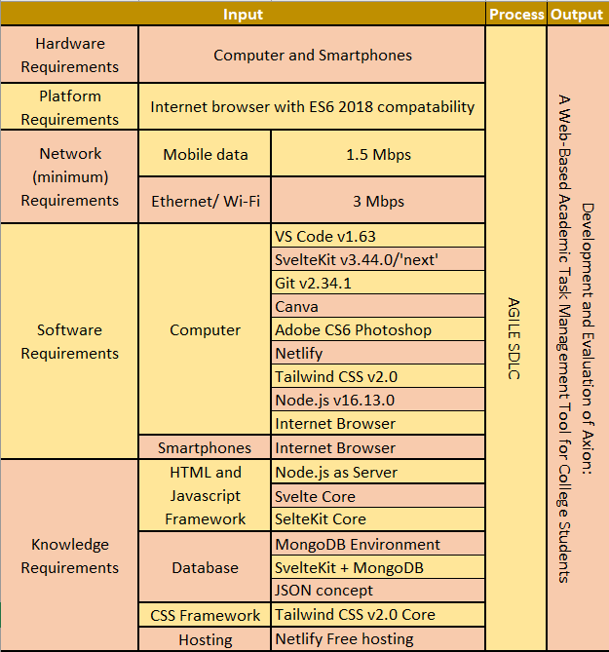

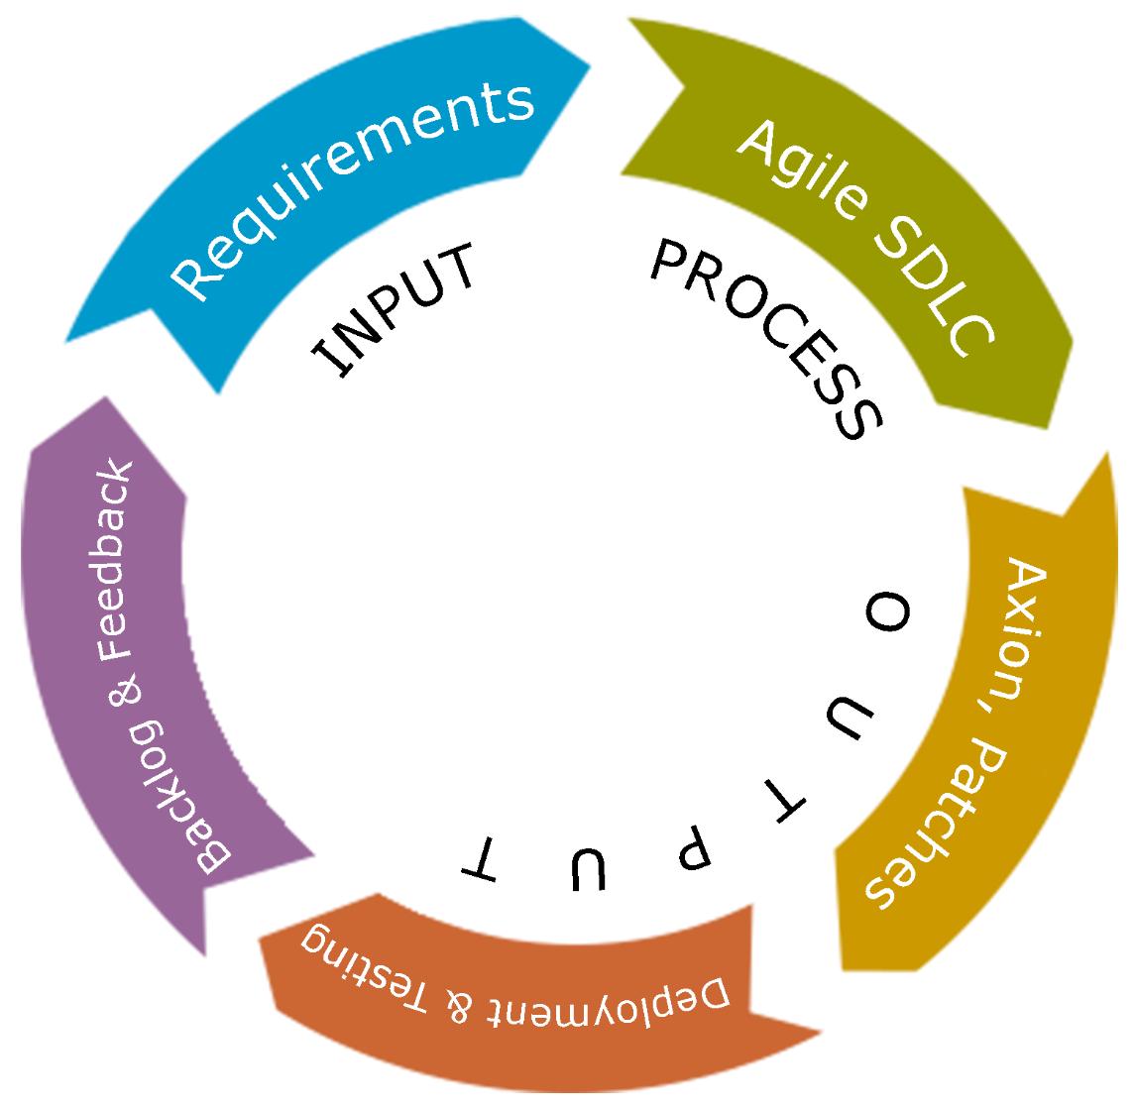

*Figure 1. IPO Model of development of Axion*

The researchers first look at the requirements to develop such system and this requirement are divided into five (5) categories. The categories are hardware, platform, network, software and knowledge requirement. Computer and smartphone for hardware requirement, as this is the most common and possible gadget that the students have. A cross-platform between windows, android and iOS is what the researchers will development as the system is web-based and runs on the internet browsers. Being online-dependent system requires stable internet connection for it to work, also this is a mandatory requirement for the researchers as they use the internet to gather information, data and to download software/s that is needed in the development. By developing requires software and this software requirement are categorized into two parts, first computer software and second smartphone software requirement to develop the system. On computer software starts with the coding environment, Visual Studio Code and inside of the code editor has any extensions and tools that can be used for better coding and development. SvelteKit and Bootstrap are frameworks that will be used to make coding faster. Git for updating and distributing files of the system especially codes. Canva for system layout and low fidelity prototyping. Canva also supports live collaboration. Adobe Photoshop CS6 for additional graphics for the system. Computer and smartphone internet browser is where the output will be displayed after development of the system. For the researchers to be able to use the software properly especially the frameworks and about database they need the knowledge about SvelteKit and Bootstrap 5 for this are the major language they will use in the development. Followed by the database connection with MongoDB through SvelteKit.

On the process, researchers use the agile software development life cycle for this development is a rapid, fast, and has always changing the system being developed. Axion is not a long term project, after the publication of the system developers will no longer update it. If the system is not yet in testing phase the output is the Axion a web-based task management tool for students’ system, else additional patches and features or fixed bugs and errors in the system.

**CHAPTER 2**

**REVIEW OF RELATED LITERATURE**

**2.1 TECHNICAL BACKGROUND (wala balita)**

Workspaces are seen, especially in enterprises, as an area to keep boards that are related to the same topic or workflow together, or even to keep all the important things for the same team and people, regardless of the subject. Workspaces provide a useful way to see boards and collaborate with all your team members in one place. Web is the area where users are able to visit through the Internet using a browser. A web browser is frequently used to execute web-based applications, which are software that is accessible through the Web over a network connection rather than being stored in memory on a device. Web-based applications can also be client-based, in which a tiny portion of the software is downloaded to the user's desktop but processing is done on an external server through the internet. The user interface (UI) is where users naturally interact with a system. The calendar system provides enterprise workspaces with a powerful visual approach to track and manage their cards, as well as their due dates and start dates. The calendar view provides users with the perspective that users need to arrange and prioritize tasks for the coming days, weeks, and months. A board is the central hub of the workplace, and it may hold any number of lists and cards. A list is a column that includes cards. It's to the users and their project's needs how they utilize and arrange lists. Each list, for example, may represent a team member, and the board would keep track of everyone's responsibilities. Alternatively, a user may set up the list as a workflow, with each card moving from one list to the next as tasks are processed and finished. Cards are the smallest units, which are used to identify tasks that must be completed. The card not only has a name, but can also contain file attachments, images, notes, and other information once being opened. If necessary, users can also make a card template that includes standard information, such as a team checklist. Cards can be opened and edited with a single click, and dragging and dropping cards between lists are as simple as dragging and dropping, allowing new users to get up and running quickly. Favorites are marked tasks in the favorites section wherein users will not have to find it along with the other tasks, making task searching faster.

**2.2 FOREIGN LITERATURE (aayusin; wala balita)**

Task management is deemed very important especially to the students because it helps them become more productive. According to Exforsys (2010), managing tasks reduces the time allotted for setting priorities and encourages the student to make use of the art of delegation. The study shows that a daily to-do list boosts individuals to be more productive around 20%. To-do lists can also refresh those who follow it away from unnecessary worries brought about by thinking of how they can finish every task on designated time. The list will serve as a guide in managing day-today tasks, especially in terms of academics and can also help to determine four kinds of individual tasks known as the Eisenhower Matrix, as introduced in a webpage by Eisenhower (n.d.): (1) urgent and important, (2) not urgent but important, (3) urgent but not important, and (4) not urgent and not important. O'Connell (2014) has added that having balance between sleep, exercise, and appropriate diet alongside an increase in “downtime” would lead to a decrease in anxiety and stress, therefore suggesting the link between time management and physical health.

**2.3 LOCAL LITERATURE (ongoing)**

Lynn (n.d) has claimed that project or task management tools have key components that can surely make lives and works of its clients easier starting with prioritization. Organizing in accordance to prioritize your tasks such that the most critical tasks are accomplished first, telling that the users can focus on how work should be approached by prioritizing tasks rather than bouncing from one item to another without direction. Second is visualization, it helps users better understand a project as a whole and dependencies become evident and collaboration becomes natural when everything is spelled out in an easy-to-understand manner. Lastly, analysis as the project or task management software provides accomplishments. This reflects that the team or manager can analyze it and use it to have another form of management. According to a NTaskManager website’s blog (2021) a project management software is a system that combines a variety of useful features and modules into a single platform to help anyone who needs to organize and plan their professional or personal tasks. Clients that use project management tools allow users to stay connected and manage roles and responsibilities at their project or tasks. On the contrary, Faust (2018) has pointed out on their blog’s post that project management software is over complicated and the reasons are because of highly customizable project management software it makes the project to have a complex control leaving out the software to be harder to adopt, implemented, learn and use another one is most of the companies making these project management software makes it size one fits’ all, giving every single feature that can be added to it making the project management software challenging to learn because of its broad and bloated features. Project management process includes time management, which, according to IceHrm's blog article, is defined as "time management in the manner you plan and organize your particular tasks and work." In addition, IceHrm (2021) stated that time management has the following advantages: no waste of time, less friction and problems and spend your time on other things. On the other hand, IceHrm (2021) blog’s article second part says if not able to do it right then a person may suffer to its disadvantages like putting on too much weight on himself, procrastination, multitasking and being unable to prioritize.

**2.4 FOREIGN STUDIES (ongoing)**

According to Juul & Norton (2017) in their study related to game systems and interfaces, newly-introduced users or players may be able to perceive and interpret the objectives of games as simple and feasible. But, it can be disrupted and framed as inefficient due to the interface and rules that are being set in the game to constrain players in achieving maximum control during gameplay. In other words, conversely, it is natural for software systems to be difficult. Therefore, the users must find the user interface of the application that they are using to be intuitive, pleasant, and easy to understand.

Sundström and Thelander (2004) have attempted to create a user interface for a web-based film production project management portal. This is created to face problems and barriers regarding information and communication exchange, and to serve as a widely accepted tool for every member within the film production department of The Chimney Pot, despite the differences of their skills and knowledge towards technology. They intend to define the user requirements, wherein the perspective of users should be focused on rather than the perspective of technology. This is done so that they can propose on what solution will be best based on it. Results have shown that it greatly enhances the portal’s quality and effectiveness. Furthermore, many potential users that are unfamiliar with technology are to be critically considered and expected when creating a user interface.

-

Farwell and Waters (2010) have referred in their study regarding favorites or bookmarks, which is also similar for Abrams, Baecker, & Chignell (1998), that in an educational setting, favorites or bookmarks, as an easily accessible collection of information that can be important or interesting to a certain student are capable of providing learning opportunities, improving learning experiences, promoting accuracy of information, and reinforcing learning objectives. However, as finalized by Bergman, Whittaker, and Schooler (2021) in their study that the bookmarks may not become capable as said, if they are not visible to the users. Grosseck (2008) has also stated that it can become an obstacle for the users, possibly causing them information overload due to having a huge amount of sources that may have been abandoned and unvisited. This can mean that students are to carefully handle their favorites section in a way that they should also recognize its use.

As for setting priorities to tasks, Bahadori, Salesi, Ravangard, Hosseini, Raadabadi, Dana, and Ameryoun (2015) have recommended that an individual should be required to have sufficient knowledge regarding his or her current situation towards his or her responsibilities in order to plan and arrange their tasks accurately and properly, starting with the activities that are most urgent and important. Due to this, the improvement of managing time and resources in a proper manner can be achieved. This can also be relevant for college students which is stated by Britton and Tesser (1991), since their methods or practices towards management may influence their academic achievements in college.

**2.5 LOCAL STUDIES (ongoing)**

The study of Heredia, Espinosa, and Caro (2014) has concluded that by utilizing triggers through the interface within the database, and using a container that will only retrieve the newly updated entries that have been updated, it can achieve effective data synchronization and the automation of the system to synchronize new updates back to all interfaces, keeping the integrity and consistency of information. Added by Barbosa and Llevado (2019), their study has also concluded that, using a database that facilitates quick registration of clients and easy monitoring can achieve offline data synchronization. The database has to be included in the synchronization since it handles and processes the data to be updated, modified, and displayed from one interface to another of all users.

**2.6 FOREIGN SYSTEMS (needs revision)**

Andriiuk (n.d.) and Kashyap (2021) have included in their lists the following systems that are related to the system of Axion:

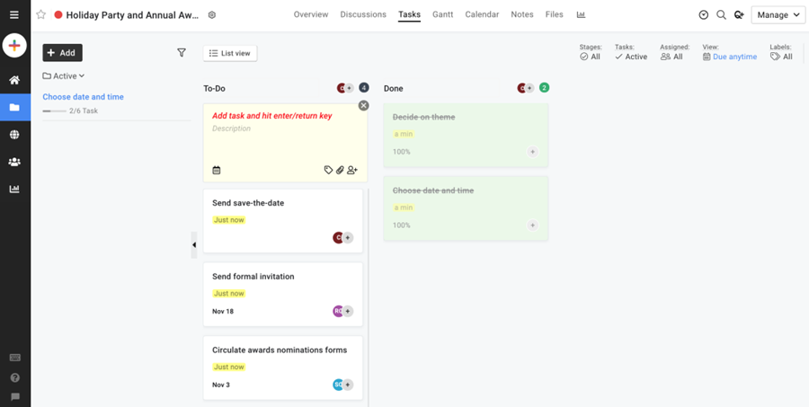

*Figure 1. ProofHub offers task management tools, milestones, Gantt charts, time tracking, reports, notifications, a calendar, in-app chat, and others.*

ProofHub gives teams a centralized location to collaborate and complete projects. Besides online collaboration, ProofHub contains capabilities for improved communication, visibility, progress monitoring, and accountability.

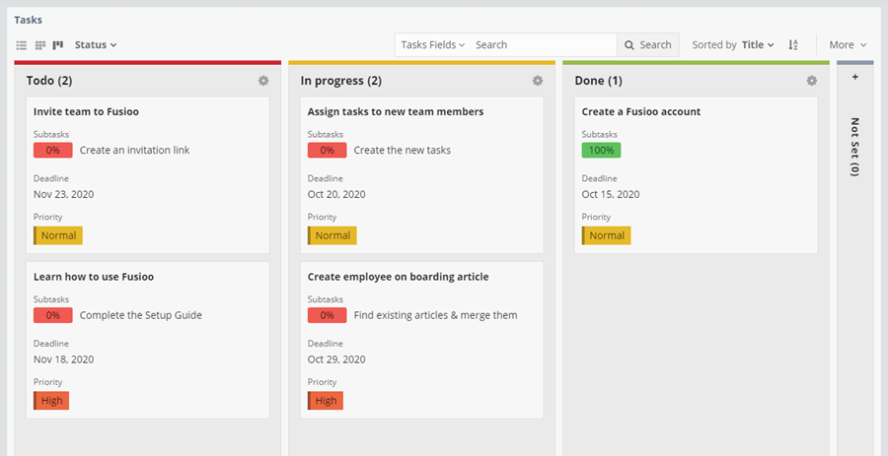

*Figure 2. Fusioo manages their workflows, stores relevant data, creates custom dashboards, visualizes data, plans projects, tracks deadlines, and more.*

Fusioo keeps track of a team's progress uniquely. It is favorable for small businesses to get organized because it lets them publish an online database in a short period of time and manage projects, clients, ideas, and timesheets in one certain location. Fusioo allows users to connect with both internal and external audiences within a secure system.

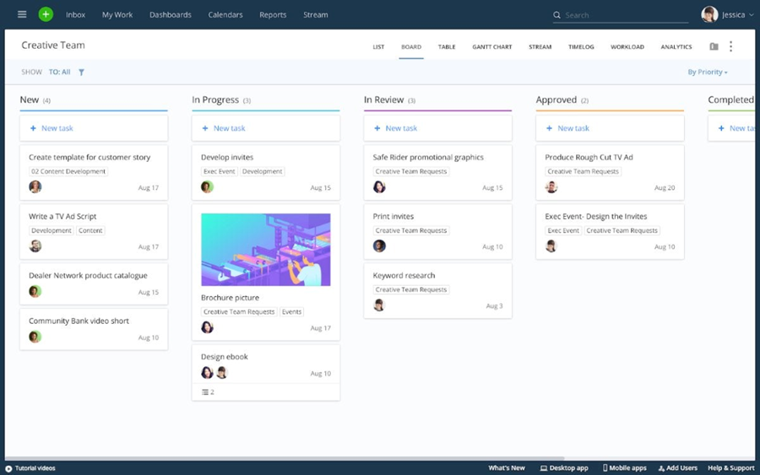

*Figure 3. Wrike has support for notifications, real-time comments, live editing, dynamic report. Wrike also makes it easy to share updates with stakeholders as needed.*

Wrike has collaboration and information management capabilities. It provides end-to-end project solutions, making and managing projects in a simple manner. Its task management and customization capabilities may help a team grow progressively.

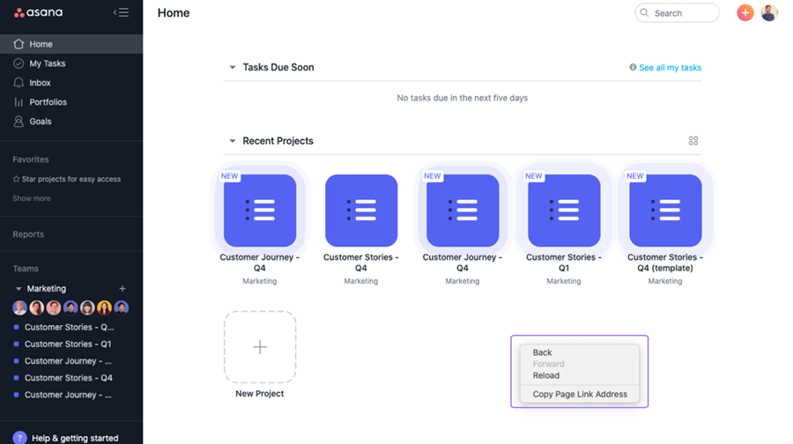

*Figure 4. Asana allows individuals and teams to divide large tasks into manageable parts, tracks the progress users make on projects and tasks, exchange files, comments, and notes, and keep track of progress and deadlines.*

Asana includes several features that can assist teams in managing tasks, information, and procedures. Asana is widely used by small firms and it effectively makes team collaboration convenient.

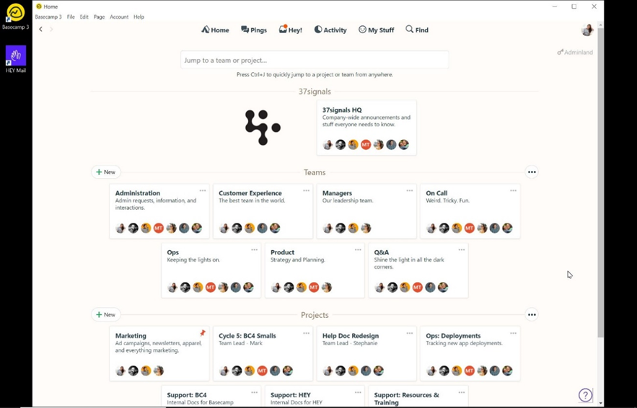

*Figure 5. Basecamp helps teams stay on the same page, despite being less on resource planning and long-term scheduling. Basecamp supports to-do-lists, calendaring, due dates and file-sharing, and provides a way for teams to keep track of priorities and actionable items.*

Basecamp is a collaboration and workstream platform and it is also a project management tool. It also incorporates a message board, real-time group chat, and other collaboration capabilities.

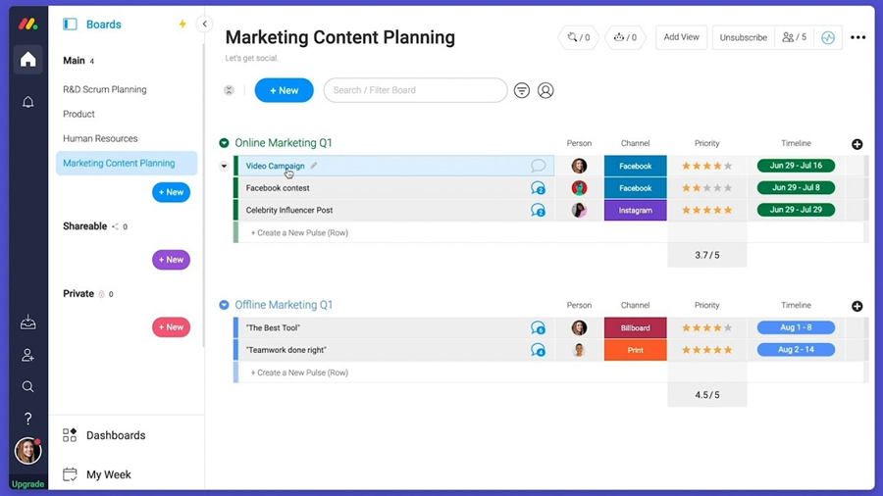

*Figure 6. Monday.com allows for ease of use and flexibility to onboard any team and manage multiple projects across the entire team. Monday.com supports time-tracking, an integrated Kanban board, automated notifications, workflow automation, dependencies, multiple views and calendar integration.*

Monday has many options regarding task management views, including a Kanban board, a list, a map, and a spreadsheet. Another appreciated feature is their reporting tool, which will make it easier for a team of users to keep track of their project's progress.

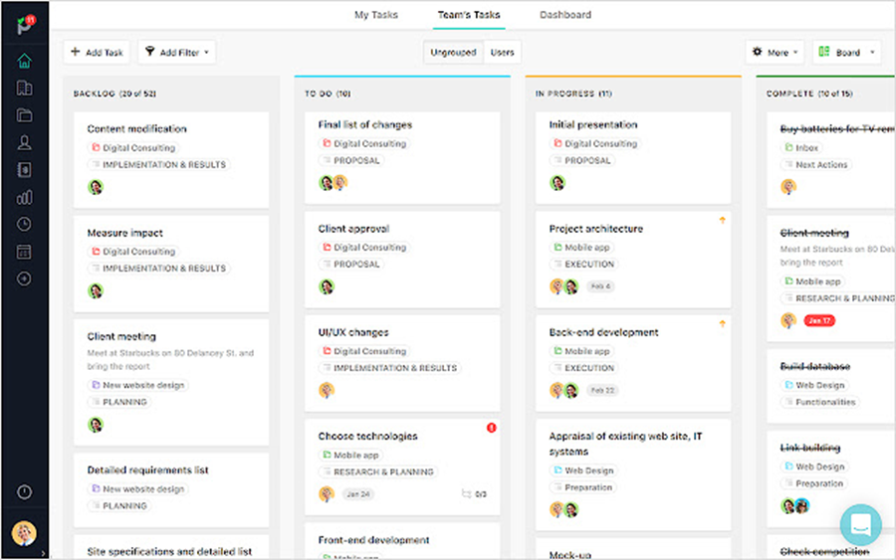

*Figure 7. Paymo is suitable for small and medium client-based businesses. Paymo supports remote work and offers project planning, resource scheduling, team collaboration, file proofing, time tracking, and project accounting within a single suite.*

Paymo assists users with resource scheduling, time tracking, project planning, accounting, file proofreading, and team collaboration. Users may create projects, check their progress using the time tracking tool, and manage their workflow using various task views such as Gantt charts, lists, tables, and Kanban boards.

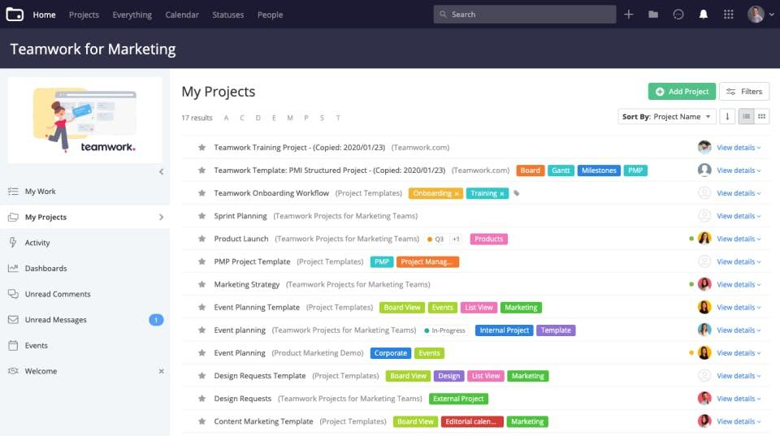

*Figure 8. Teamwork provides businesses functionalities to manage different operations of a project. Features include task lists, time tracking, file uploads and messages. Teamwork helps teams manage group objectives, communicate and establish business processes.*

Teamwork can be a good option to manage tasks, but it can also become sophisticated to users. Workload and portfolio management, time tracking, reporting dashboards, board view, and Gantt charts are what Teamwork can provide. It will allow users to manage many complex projects at the same time.

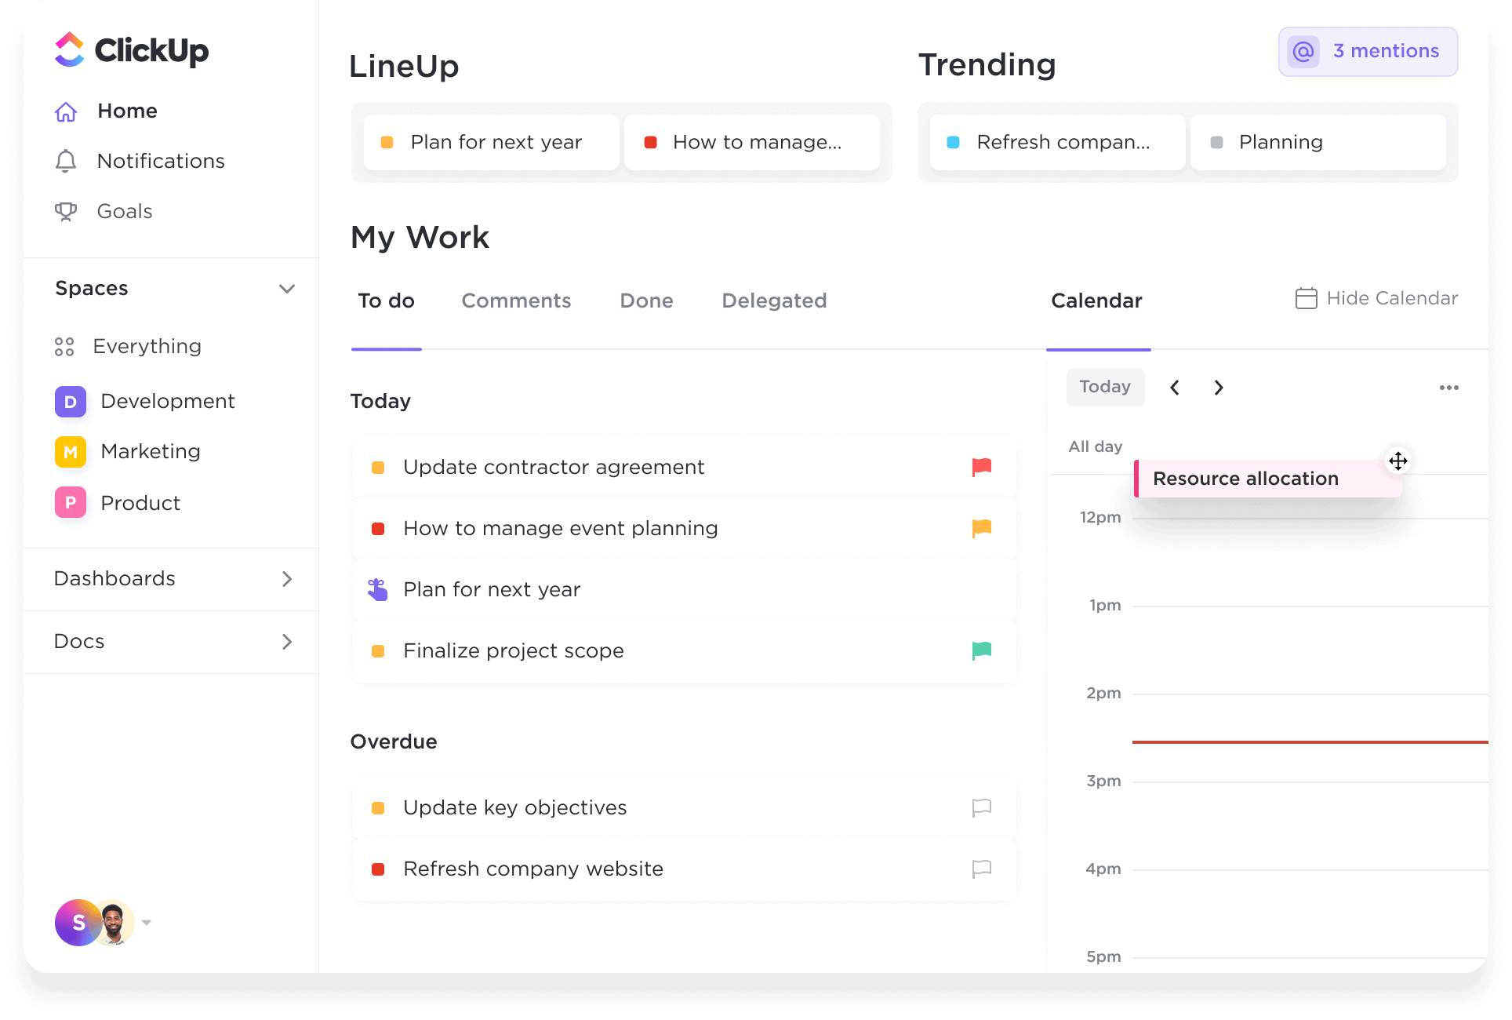

*Figure 9. Clickup includes the features of Kanban board, schedule tasks, subtasks, and even chat with their team members to enhance collaboration.*

ClickUp lets users plan, schedule, and manage their projects through Kanban boards. It will allow them to access a broader range of tools, such as Gantt charts and timeframes. To improve teamwork, users may plan tasks, subtasks, and even talk with their collaboration.

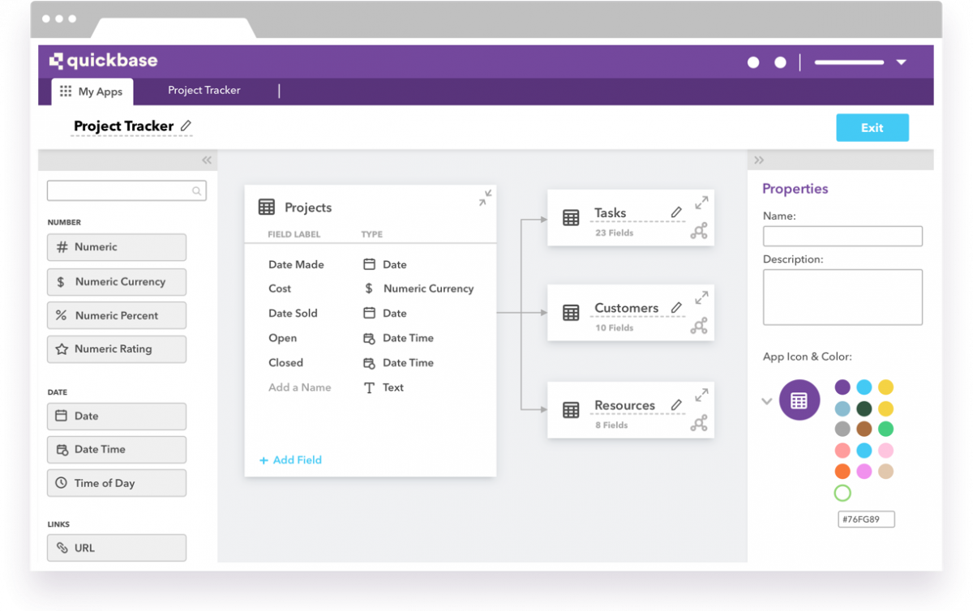

*Figure 10. Quickbase tables can organize data like spreadsheets, but are much more powerful. It collaborates through teams and sees information through real-time..*

QuickBase enables users to build more efficient methods of working. It facilitates communication by providing a platform for hundreds of team members, colleagues, and clients to interact and achieve productivity. Because QuickBase is a collection of programs, it is considerably adaptable and can be utilized through different means.

**2.7 PROJECT SYNTHESIS (needs deep revision; requires RRLS finished)**

Exforsys (2010), have stated that managing tasks can invest more time and resources for other things that can be unimportant and/or not urgent, such as hobbies. By doing so, functionalities of a task management tool will be significant to help users not only achieve their desired goals by managing their resources, but also to invest more of them in the future. According to Faust (2018), task management tools with high functionalities and features tend to be more complex due to having a wider area for the users to control, which would likely make the users feel confused and overwhelmed. The users may find it more difficult to adapt to the whole system, possibly affecting their productivity in a negative way, and lessening the capabilities to plan, learn, and use. Therefore, having a brief map of the system may reduce the time being spent by users on learning it, but it shouldn’t affect the specific objective of the system. In another statement by Lynn (n.d) that having effective resources can make the users work rationally and gain more success. It would be significant for a task management tool to indicate its specifications that strive to achieve a unique objective, so that users can know what it will be for and how it should be used. A specification included, like what Heredia, Espinosa, and Caro (2014) and Barbosa and Llevado (2019) have stated and concluded in their studies, is the system being automated to synchronize newly updated data to other screens of users through the database, which is what Axion is involving. This can be done through the collaboration of students when working on group activities, whether one or more members are offline, as long as data is updated, it will sync to other screens.

ProofHub, Fusioo, Wrike, Asana, Basecamp, Monday, Paymo, Teamwork, ClickUp, and Quickbase are the following management tool systems that are considerably related to Axion. The said related systems share the similar user interface, system structure, and objective. As concurred by Esmeria & Seva (2017), Juul & Norton (2017), the user interface is considerably one of the most crucial components for any application, since it heavily displays how effective systems are. It will also be defining how easy or difficult the whole system is to grasp, as Ramrathan and Sibanda (2017) have seconded. The contemporary, minimalistic system design is used by the related systems, since it indicates consistency and modernness. As for Axion, the researchers intend to make the user interface of Axion more perceptive by exhibiting more color and fun-looking fonts. Sundström and Thelander (2004) considers that there would be potential users that are still familiarizing themselves with technology as an academic tool. Axion aims to be capable of welcoming them through its system design. This feature is what makes Axion mainly unique than the said related systems, which appears to impress higher occupations. Additionally, the researchers aim to provide a semi-casual voice and tone to static texts not only to match the user interface, but also to let the college students keep the formalities during their usage.

Another specific feature of Axion is the management system that is developed for users to find it comprehensible, intuitive, and quick to grasp. This is considerably included, for college students may find it complicated to control an entire system of the management tool. Being followed by Coursaris & Kim (2011), it might create a gap between the complexity of the system and the interaction of users to it. Axion has features similarly to other related systems, but it specifically aims to focus on what students can work on within its system.

Favorites, which can also be referred to as bookmarks, are implemented in the system to offer students the ability to have faster access to tasks that they have marked, reducing their effort to look for them. Farwell and Waters (2010), Abrams, Baecker, & Chignell (1998) have supported the purpose of favorites or bookmarks and how it is still supported in any forms of application, despite Bergman, Whittaker, and Schooler (2021) and Grosseck (2008) telling the delimitations regarding bookmarks about how it should be visible to be useful and to be manage to avoid information overload. Although some of the related systems of Axion have already featured a favorites or bookmark feature, the researchers consider to be more specific with it by covering elements from both individual and group workspaces, whether it can be a board, task, or a subtask. but

Priorities are also included in most of the related systems, yet only a few emphasize the tasks with the highest priority. Lynn (n.d), Bahadori et al. (2015), and Britton and Tesser (1991) concurred on how prioritization should be considered to even make management more effective. In Axion, a Kanban system will be mainly used by students and to highlight the tasks that need the most attention, Axion automatically sorts any tasks on a desired board from top to bottom, starting with the highest priorities at the top and the lowest priorities at the bottom. Supposing that the users’ reading order is from top to bottom, they’ll be able to see the tasks with the highest priority first. This is also to assert recognizability, stimulating the idea of proper prioritization to students.

**2.8 TABLE OF COMPARISON (aayusin)**

**LITERATURE**

|  |  |  |  |  |  |  |  |  |  |  |
| --- | --- | --- | --- | --- | --- | --- | --- | --- | --- | --- |
| System features | **ProofHub** | **Fusioo** | **Wrike** | **Asana** | **Basecamp** | **Monday** | **Paymo** | **Teamwork** | **ClickUp** | **QuickBase** |
| User-friendly, visually unique GUI | No | No | No | Yes | No | Yes | No | No | Yes | No |
| Easy-to-learn management system | No | Yes | Yes | No | Yes | No | Yes | No | No | No |
| Favorites | Yes | No | Yes | Yes | No | Yes | No | No | No | No |
| Sorting and emphasizing high-priority tasks | No | No | Yes | Yes | No | Yes | No | No | No | Yes |

**STUDIES**

|  |  |  |  |  |  |  |  |  |  |  |
| --- | --- | --- | --- | --- | --- | --- | --- | --- | --- | --- |
| System features | **ProofHub** | **Fusioo** | **Wrike** | **Asana** | **Basecamp** | **Monday** | **Paymo** | **Teamwork** | **ClickUp** | **QuickBase** |
| User-friendly, visually unique GUI | No | No | No | Yes | No | Yes | No | No | Yes | No |
| Easy-to-learn management system | No | Yes | Yes | No | Yes | No | Yes | No | No | No |
| Favorites | Yes | No | Yes | Yes | No | Yes | No | No | No | No |
| Sorting and emphasizing high-priority tasks | No | No | Yes | Yes | No | Yes | No | No | No | Yes |

**SYSTEMS**

|  |  |  |  |  |  |  |  |  |  |  |
| --- | --- | --- | --- | --- | --- | --- | --- | --- | --- | --- |
| System features | **ProofHub** | **Fusioo** | **Wrike** | **Asana** | **Basecamp** | **Monday** | **Paymo** | **Teamwork** | **ClickUp** | **QuickBase** |
| User-friendly, visually unique GUI |  |  |  | Yes |  | Yes |  |  | Yes |  |
| Easy-to-learn management system |  | Yes | Yes |  | Yes |  | Yes |  |  |  |
| Favorites | Yes |  | Yes | Yes |  | Yes |  |  |  |  |
| Sorting and emphasizing high-priority tasks |  |  | Yes | Yes |  | Yes |  |  |  | Yes |

**REFERENCES**

Abrams, D., Baecker, R., & Chignell, M. (1998). Information archiving with bookmarks: Personal Web space construction and organization. *Proceedings of the SIGCHI Conference on Human Factors in Computing Systems,* 41-48. https://doi.org/10.1145/274644.274651

Adams, R. V., & Blair, E. (2019). *Impact of time management behaviors on undergraduate engineering students’ performance*. SAGE Open, 9(1), 215824401882450. https://doi.org/10.1177/2158244018824506**\**

Andriiuk, A. (2021, June 3). 9 best Trello alternatives to watch for in 2021. Retrieved from https://www.forecast.app/blog/trello-alternatives

Anjali J. (2021, February 15). *What is organizing? Definition, process and principles*. The Investors Book. Retrieved from https://theinvestorsbook.com/organizing.html

Bahadori, M., Salesi, M., Ravangard, R., Hosseini, S. M., Raadabadi, M., Dana, A. H., & Ameryoun, A. (2015, November 26). Prioritization of factors affecting time management among health managers. *International Journal of Travel Medicine and Global Health, 3*(4), 169-174. http://dx.doi.org/10.20286/ijtmgh-0304142

Barbosa, J. B., & Llevado, J. C. (2019). A mobile-based monitoring system for micro small medium enterprises (MSMEs) with offline data synchronization. *Indian Journal of Science and Technology, 12*(35), 1-10. https://dx.doi.org/10.17485/ijst/2019/v12i35/145302

Barrot, J. S., Llenares, I. I., & del Rosario, L. S. (2021). Students’ online learning challenges during the pandemic and how they cope with them: The case of the Philippines. *Educ Inf Technol, 26*, 7321–7338. https://doi.org/10.1007/s10639-021-10589-x

Bergman, O., Whittaker, S., & Schooler, J. (2021). Out of sight and out of mind: Bookmarks are created but not used. *Journal of Librarianship and Information Science, 53*(2), 338–348. https://doi.org/10.1177/0961000620949652

Bhatti, S., Dewani, A., Hafiz, T., Noor, P., & Memon, M.G. (2018, February). Management of non-behavioral tasks via auto reminder and notifier. *International Conference on Advancements in Computational Sciences (ICACS)*. Retrieved from https://www.researchgate.net/publication/324379210_Management_of_non-behavioral_tasks_via_auto_reminder_and_notifier

Britton, B. K., & Tesser, A. (1991, September). Effects of time-management practices on college grades. *Journal of Educational Psychology, 83*(3), 405-410. http://dx.doi.org/10.1037/0022-0663.83.3.405

Calvet, L., Marquès, J. M., Arguedas, M., Daradoumis, T., & Mor, E. (2021, June 7). Using a notification, recommendation and monitoring system to improve interaction in an automated assessment tool: An analysis of students' perceptions. Taylor & Francis. https://www.tandfonline.com/doi/full/10.1080/10447318.2021.1938400

Canada, T. (2019, October 31). *Project management software advantages and disadvantages*. Medium. Retrieved on November 6, 2021 from https://medium.com/@tenderly/project-management-software-advantages-and-disadvantages-c8dfa89d5d10

Carter, T. (2020, August 18). Notifications are killing your productivity -- here's what to do about it. Entrepreneur. Retrieved on November 9, 2021 from https://www.entrepreneur.com/article/354788

Connors, C. D. (2018, Novermber 16). *The feeling of achievement — 10 ways celebrating success improves your life*. Medium. https://medium.com/the-mission/the-feeling-of-achievement-10-ways-celebrating-success-improves-your-life-41532a964ff3

Coursaris, K., & Kim, D. J. (2011). A meta-analytical review of empirical mobile usability studies. *User Experience Professionals Association, 6*(3), 117–171. Retrieved from https://www.researchgate.net/publication/262273708_A_Meta-Analytical_Review_of_Empirical_Mobile_Usability_Studies

Disability Resource Center. (n.d.). *Differences between high school and college*. Clackamas Community College. https://www.whitworth.edu/cms/media/whitworth/documents/administration/educational-support-services/differences-between-high-school-and-college.pdf

Esmeria, G. J., & Seva, R. R. (2017). *Web usability: A literature review*. https://xsite.dlsu.edu.ph/conferences/dlsu-research-congress-proceedings/2017/SEE/SEE-I-013.pdf

Exforsys. (2010, July 22). Importance of task management. Exforsys Inc. http://www.exforsys.com/career-center/task-management/importance-of-task-management.html#:~:text=In%20essence%2C%20task%20management%20istasks%20which%20are%3A%20urgent%20and

Farwell, T. M., & Waters, R. D. (2010). Exploring the use of social bookmarking technology in education: An analysis of students’ experiences using a course-specific delicious.com account. *MERLOT Journal of Online Learning and Teaching, 6*(2). https://repository.usfca.edu/cgi/viewcontent.cgi?article=1020&context=pna

Faust, B. (2018, September 4). Why we’re building yet another task management platform. https://rindle.com/blog/why-were-building-yet-another-task-management-platform

Gloria, M., Gudith, D., & Klocke, U. (2008, April). The cost of interrupted work: More speed and stress. *Proceedings of the SIGCHI Conference on Human Factors in Computing Systems,* 107-110. https://dl.acm.org/doi/10.1145/1357054.1357072

Grosseck, G. (2008). The role of Del.icio.us in education: creating significant learning experiences. http://www.scribd.com/doc/2413801/The-Roleof-Delicious-in-Education.

Gutierrez, R. I. A. (2021, February 24, February 26, March 1). How to effectively control tasks and people [Conference session]. Employers Confederation of the Philippines, Makati, Metro Manila, Philippines.  https://ecop.org.ph/event/how-to-effectively-control-tasks-and-people/2021-03-01/

Heredia, G., Espinosa, K. J., &  Caro, J. (2014, January 7-9). A data synchronization model in mobile electronic medical record for operational efficiency. *Proceedings of the 2014 International Conference on Industrial Engineering and Operations Management.* http://iieom.org/ieom2014/pdfs/569.pdf?fbclid=IwAR0n-FtUgSP43s5QpLrLm2D13KC59PvhDQOTCLsfo_aBb_36jzEFrTPuyVY

IceHRM. (2020, January 22). Advantages and disadvantages of time management. https://icehrm.com/blog/advantages-and-disadvantages-of-time-management/

Introducing the Eisenhower matrix. (n.d.). *Eisenhower.* Retrieved from https://www.eisenhower.me/eisenhower-matrix/

Juneha, P. (n.d.) *What is management?* Management Study Guide. https://www.managementstudyguide.com/what_is_management.htm

Juul, J., & Norton, M. (2009). Easy to use and incredibly difficult: on the mythical border between interface and gameplay. *In Proceedings of the 4th International Conference on Foundations of Digital Games,* 107-112. http://dx.doi.org/10.1145/1536513.1536539

Kashyap, V. (2021, November 17). 54 best project management tools & software for 2021. Retrieved from https://www.proofhub.com/articles/top-project-management-tools-list

Lam, T. (n.d.). Time management: A key to success. *Filipino Journal, 29*(8). Retrieved from  https://filipinojournal.com/time-management-a-key-to-success/

Lincoln, S. (n.d.). *12 academic tools and resources useful for university students.* MyPrivateTutor. https://www.myprivatetutor.ae/blog/12-academic-tools-and-resources-useful-for-university-students

Lualhati, G. P. (2019). Time management practices of educators in a state university. *PUPIL: International Journal of Teaching,* *Education and Learning, 3*(1), 281-289. https://dx.doi.org/10.20319/pijtel.2019.31.281289

Lynn, R. (n.d.). *What is a task management tool?* Planview. https://www.planview.com/resources/articles/lkdc-task-management-tool/

MacKay, J. (2018, June 20). *What is task management? how to break a project down into (actionable) tasks.* Planio. https://plan.io/blog/what-is-task-management/

Milano, S. (2021, July 26). Challenges of poor team communication work. Retrieved from https://work.chron.com/challenges-poor-team-communication-8813.html

NTask. (2021, February 25). 6 Best project management tools for educational institutes & students. https://www.ntaskmanager.com/blog/best-project-management-tools-for-educational-institutes/

Partner, B. (2021, September 30*). What is planning? Meaning and definition of planning.* Bench Partner. https://benchpartner.com/what-is-planning-meaning-and-definition-of-planning

Planio GmbH. (n.d*.). What is task management? How to break a project down into (actionable) tasks.* Planio. Retrieved from https://plan.io/blog/what-is-task-management/#what-is-task-management

Rhodes, K. (2017, May 20). *College allows students to exercise independence*. The Trumpet. https://thetrumpetwlu.org/4207/opinion/college-allows-students-exercise-independence/

Rios, R. (2016, June 22). *Managing time effectively.* The Freeman. https://www.philstar.com/the-freeman/cebu-lifestyle/2016/06/22/1595490/managing-time-effectively

Rotas, E. E., & Cahapay, M. B. (2020). Difficulties in remote learning: Voices of Philippine university students in the wake of COVID-19 crisis. *Asian Journal of Distance Education, 15*(2), 147-158. https://doi.org/10.5281/zenodo.4299835

Sundström, S., & Thelander, E. (2004). Designing a user interface for web-based project management in film production. Retrieved from https://www.diva-portal.org/smash/get/diva2:19735/FULLTEXT01.pdf

Techopedia. (2015, June 2). *Task management*. Techopedia.Com. https://www.techopedia.com/definition/9652/task-management

*The importance of technology in Philippine education.* (2021, March 15). Childhope. https://childhope.org.ph/importance-of-technology-in-philippine-education/

Urueña, A., Arenas, A., & Hidalgo, A. (2018, May 3). Understanding workers’ adoption of productivity mobile applications: a fuzzy set qualitative comparative analysis (fsQCA). *Economic Research-Ekonomska Istraživanja, 31*(1), 967-981. https://doi.org/10.1080/1331677X.2018.1436451

Warren, G. (2021, June 25). *What are browser-based tools and applications?* Lifewire. https://www.lifewire.com/what-are-browser-based-tools-2377407

*What is a task in project management?* (n.d.). Wrike.https://www.wrike.com/project-management-guide/faq/what-is-a-task-in-project-management/

**APPENDICES**

**LOW FIDELITY PROTOTYPE (needs more descriptions siguro)**

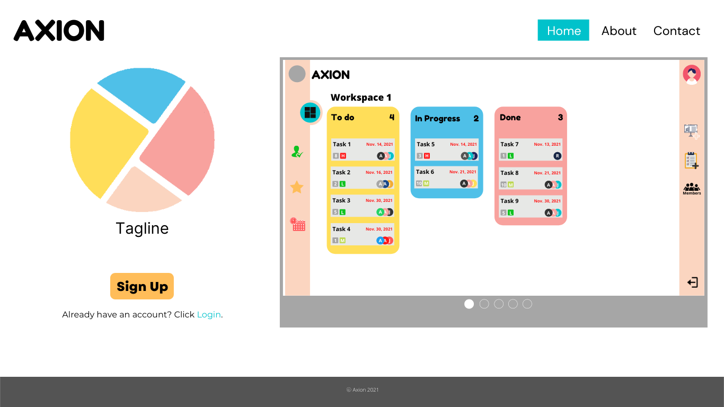

The landing page of Axion is what a first-time visitor will see. Landing page highlights the Sign Up button with warm yellow-orange color for easy to catch the eye of the visitor attempting to try and sign up in the Axion else if the visitor already has an account he/she can log in already by clicking the Login keyword below the Sign Up button. Additionally, has a carousel on the right side for the overview of what could be the Axion inside of the web-application. With three (3) navigation menus “Home”, “About” and “Contact” are pages for each small website or introductory about Axion and its developers which mainly can be contacted via the information provided in the Contacts page.

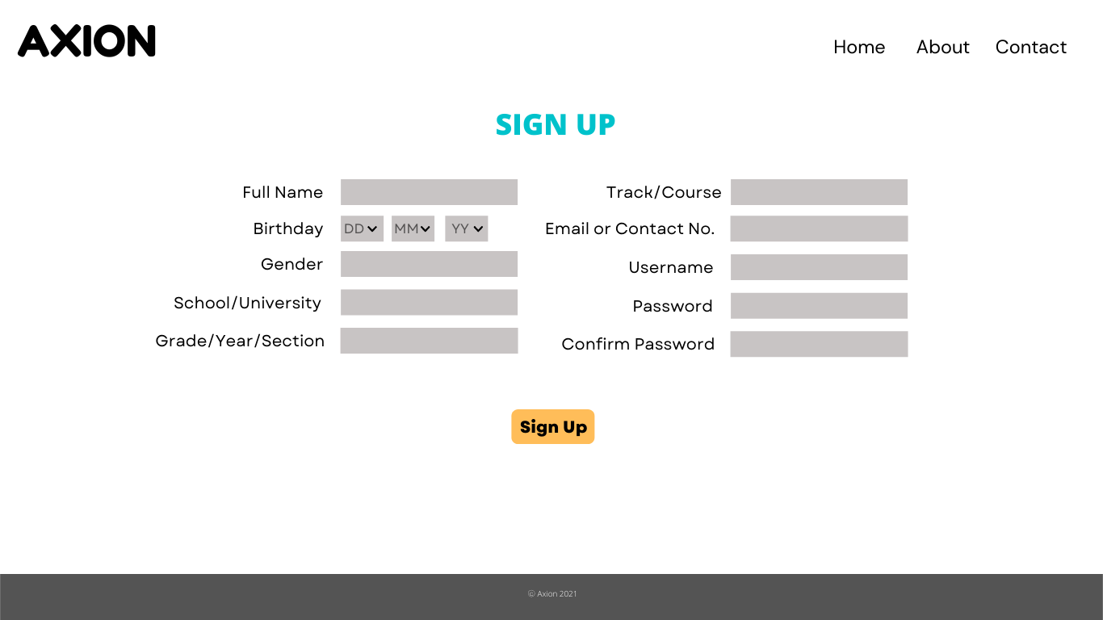

For the first time to use or new users who will sign up to use the Axion this page gets information from the soon to be user of Axion or the visitor. This information will be then encrypted, especially the credentials to be used to login to avoid any data leak and personal identity thief cases, this will be then uploaded and recorded in Axion's online database where all the information.

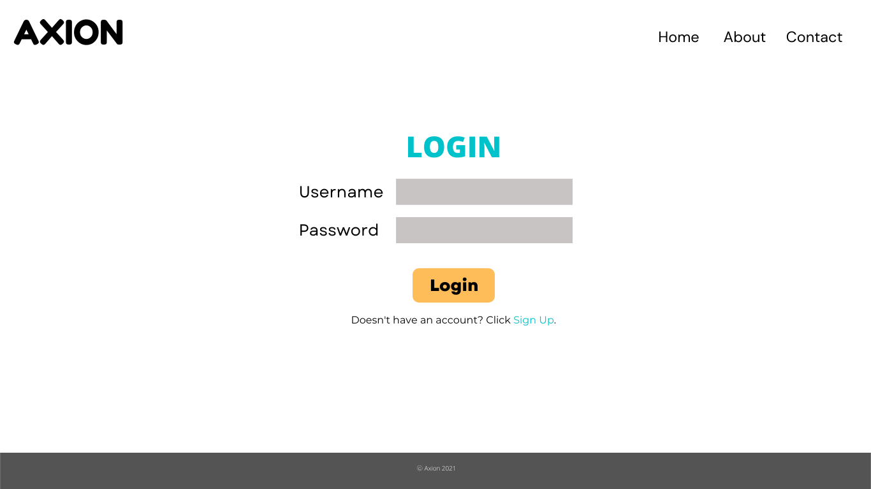

If the user has already an account the website will automatically go to the login page for the ease of the user to login on the Axion. This page requires the credentials to login in which the password will be seen as an asterisk or “password-text” style to avoid others to see the actual password. If the one who is using the device to access the Axion, Login page has the Sign up link below the Login button for them to directly go to the page of the Sign up.

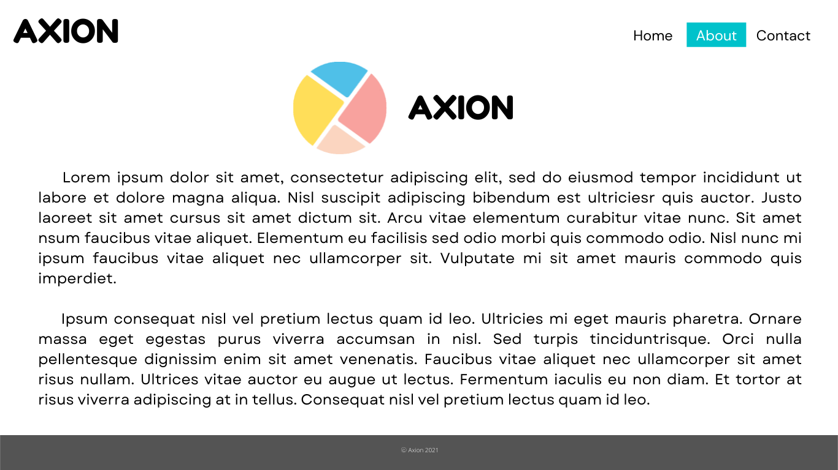

Axion website’s About page is all about telling what is Axion and what are its features and the reason why there is such a system like this. More of this will be tackled and discussed by the developers.

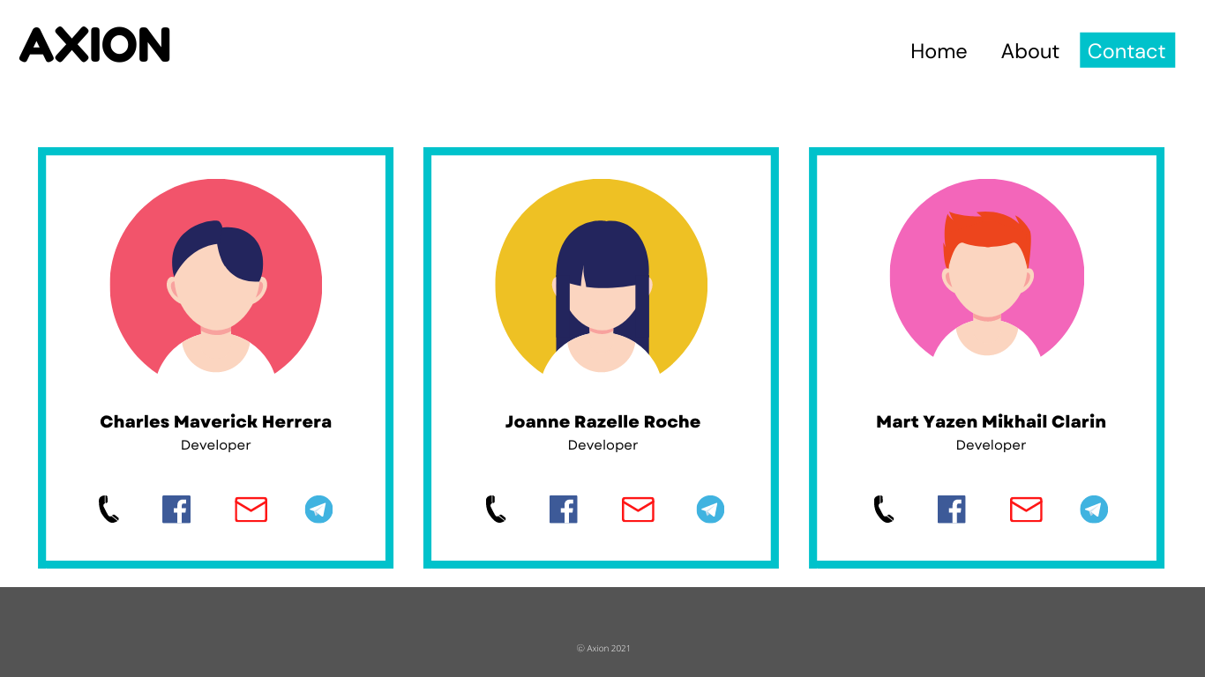

Axion website’s Contact page, contains the contact information of the developers.

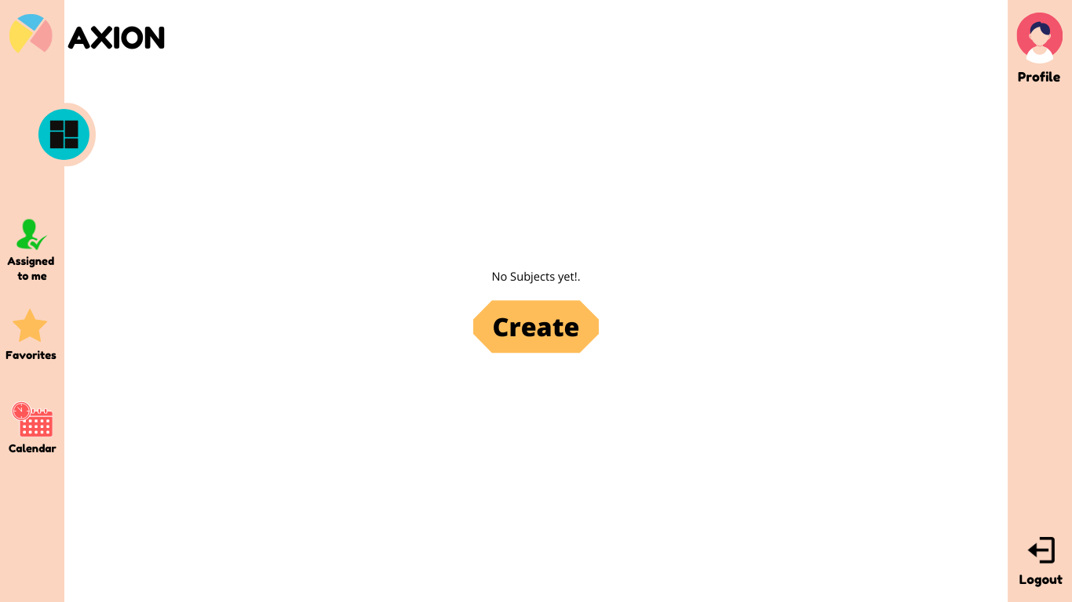

Given that the new user and refreshing old users who deleted all subjects, this is the screen or page that they will see. There will be a ‘Create’ button that attempts the user to create a new subject that they will work on with their members added.

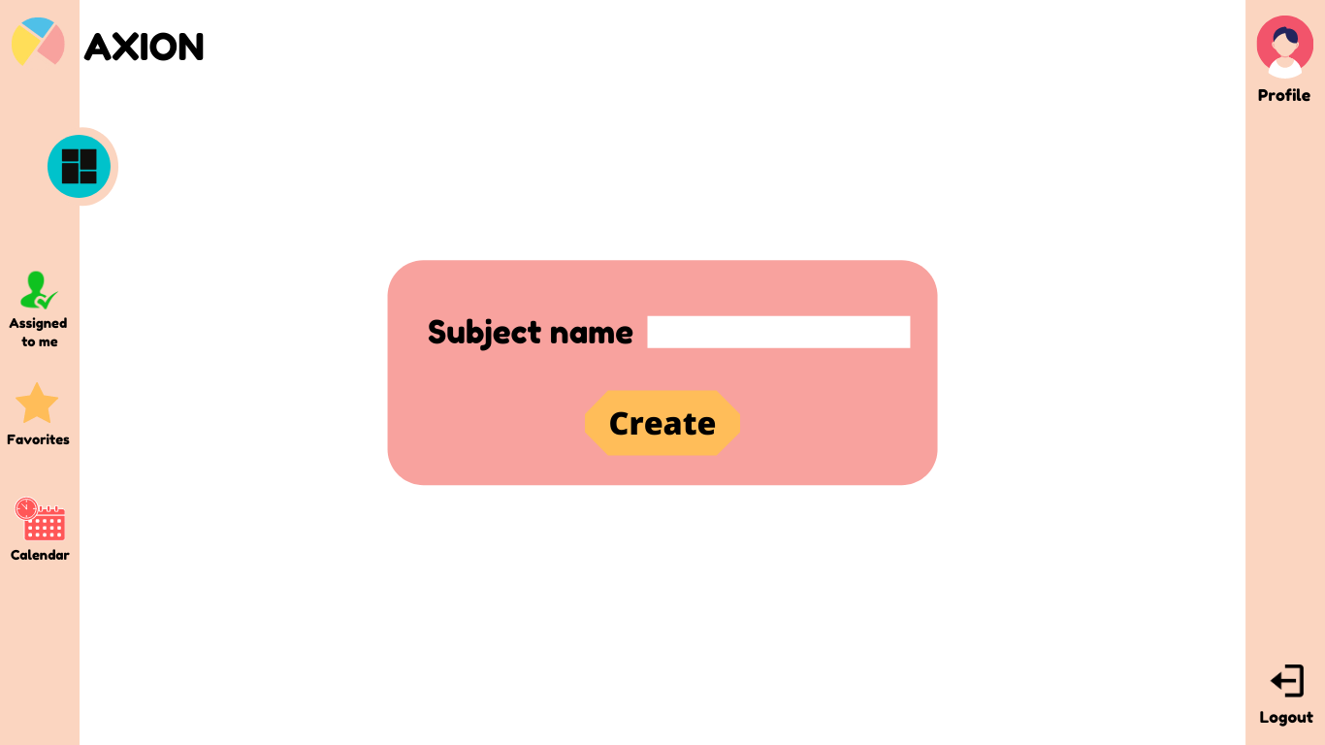

When attempting to create a subject, a small, pink box will appear that will require the user to fill up the subject name on the white blank. Pressing the ‘Create’ button will instruct the application to create the subject along with its subject name.

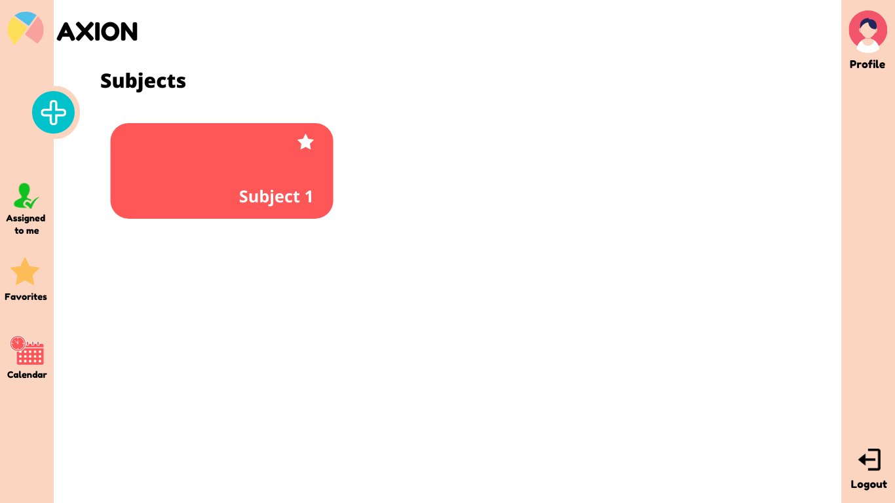

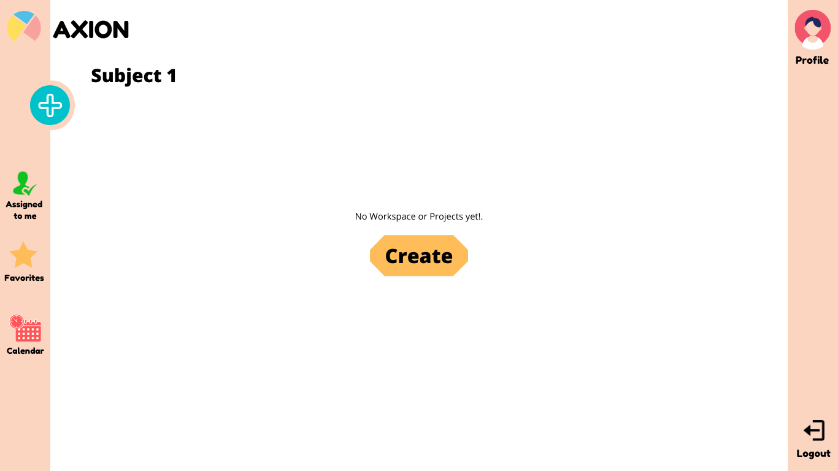

This screen or page will appear after pressing a certain subject. It will be a default for a new subject to have no workspaces or projects. There will be a ‘Create’ button that attempts the user to create a new workspace.

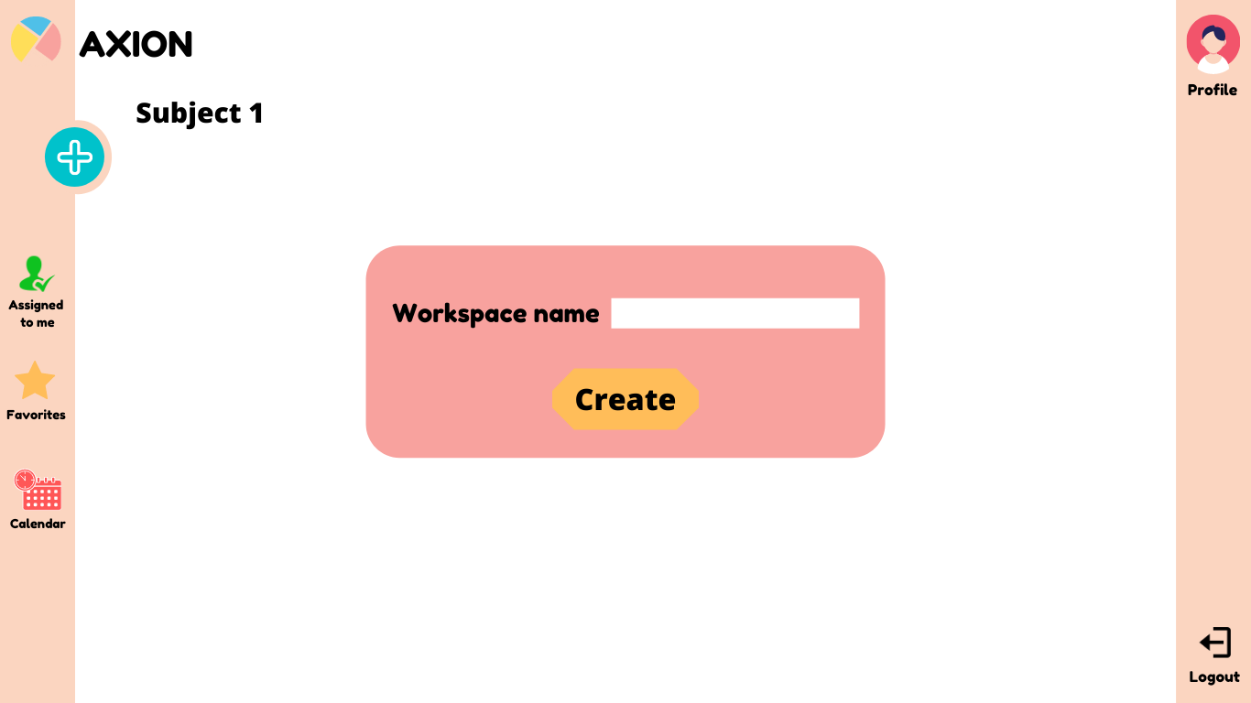

Attempting to create a workspace, a small, pink box will appear that will require the users to fill up the workspace name on the white blank. Pressing the ‘Create’ button will command the application to create the workspace along with its name.

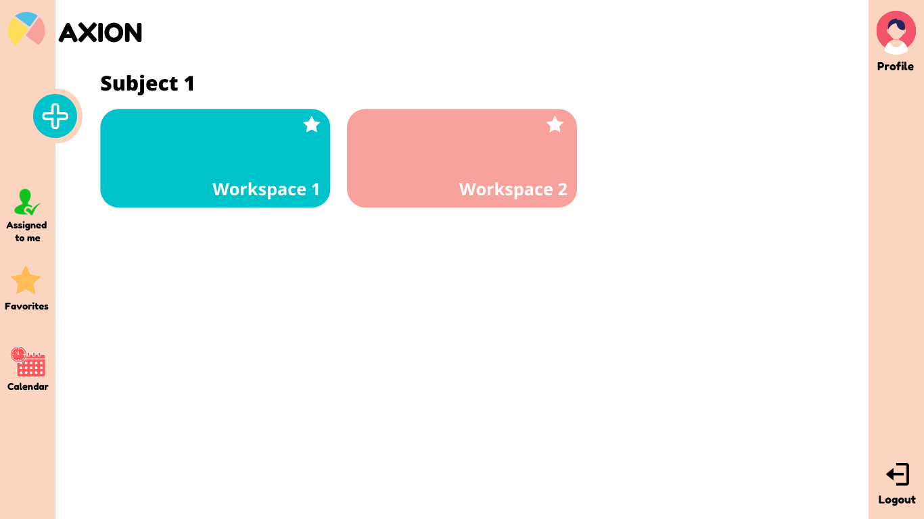

After pressing the ‘Create’ button during the process of creating a workspace, this screen can appear. As shown, there are two examples of workspaces that are created: ‘Workspace 1’ with a blue color, and ‘Workspace 2’ with a pink color.

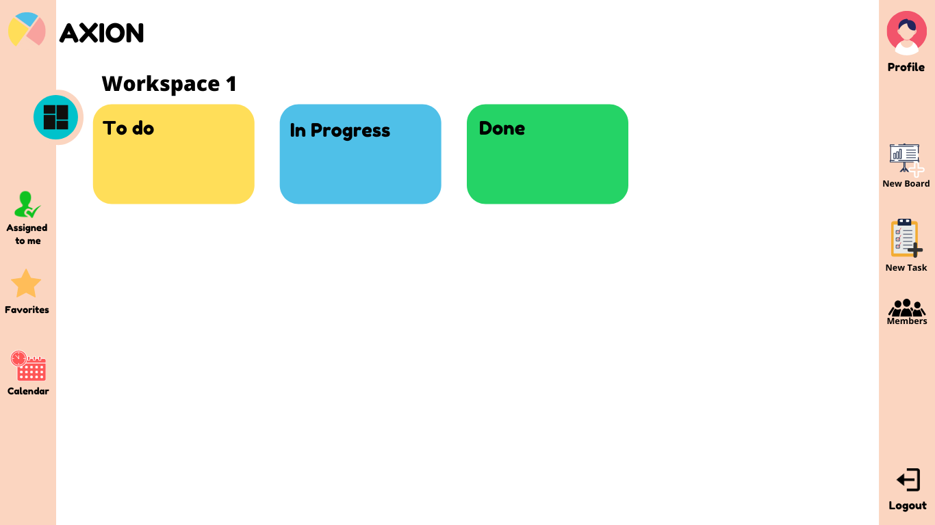

Clicking on ‘Workspace 1’ will move the user to this screen, wherein it is being structured as a Kanban board or system. The workspace will have 3 areas: the yellow ‘To Do’ section, which will list tasks that have no progress and are about to be worked on by the user. Then, the blue ‘In Progress’ section refers to the tasks that has progress and are being worked on by the user. Lastly, the green ‘Done’ section, which shows the tasks that are finished or done.

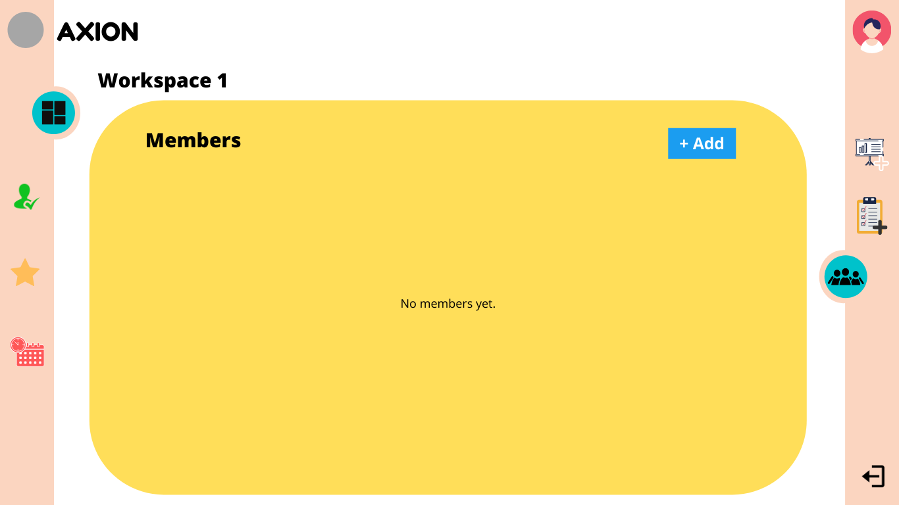

**12a**

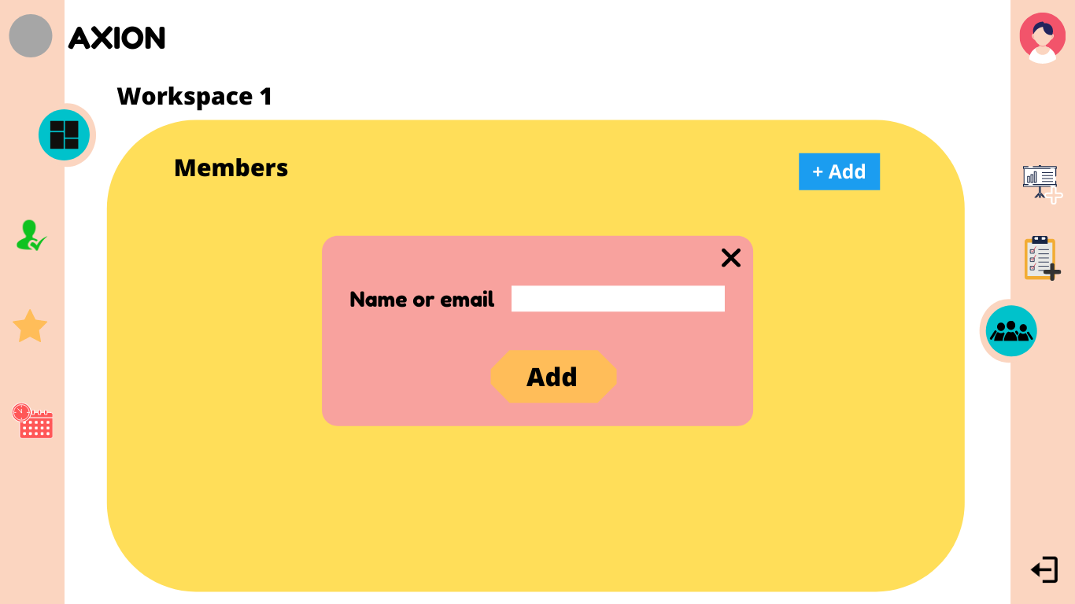

After pressing the blue ‘+Add’ button at the top right part, a small, pink box will appear which tells the user to put the name or the email address of the member that the user wants to add or invite to the workspace.

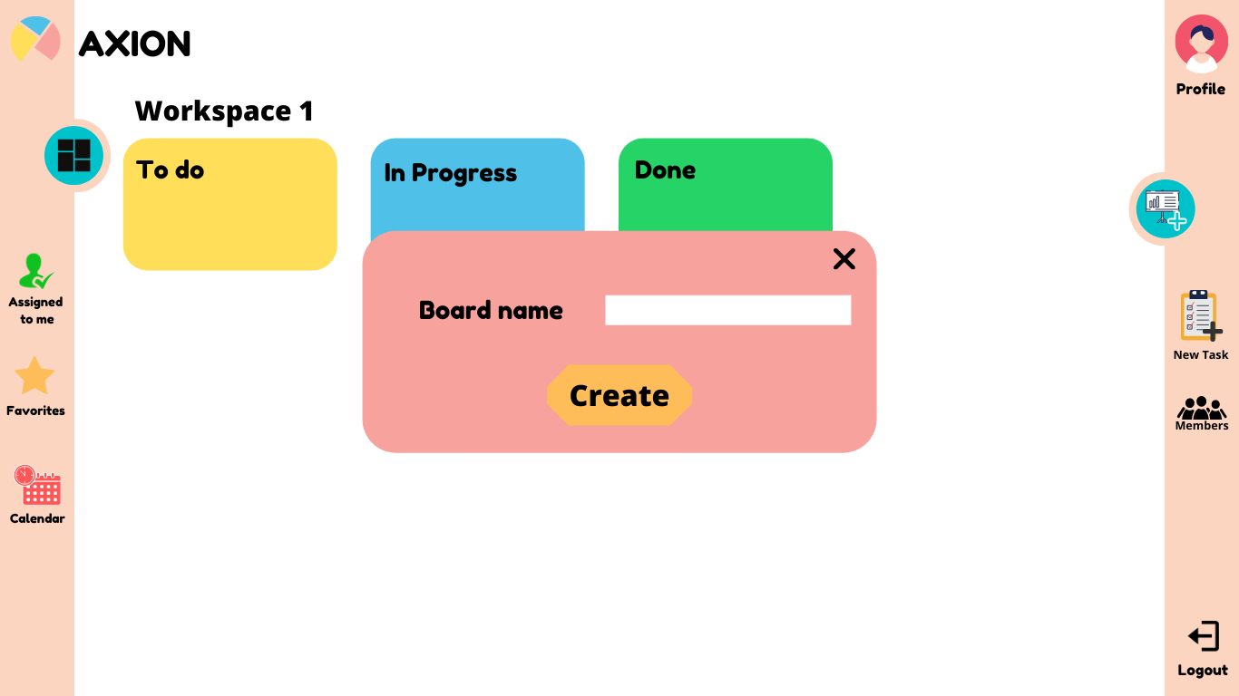

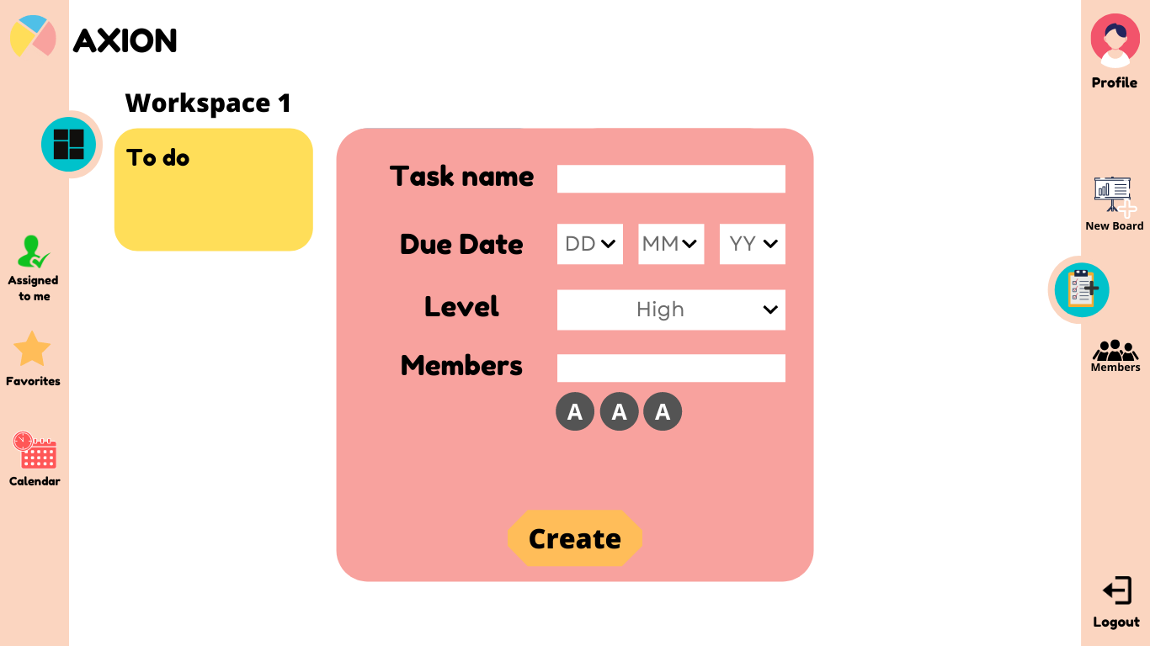

**14**

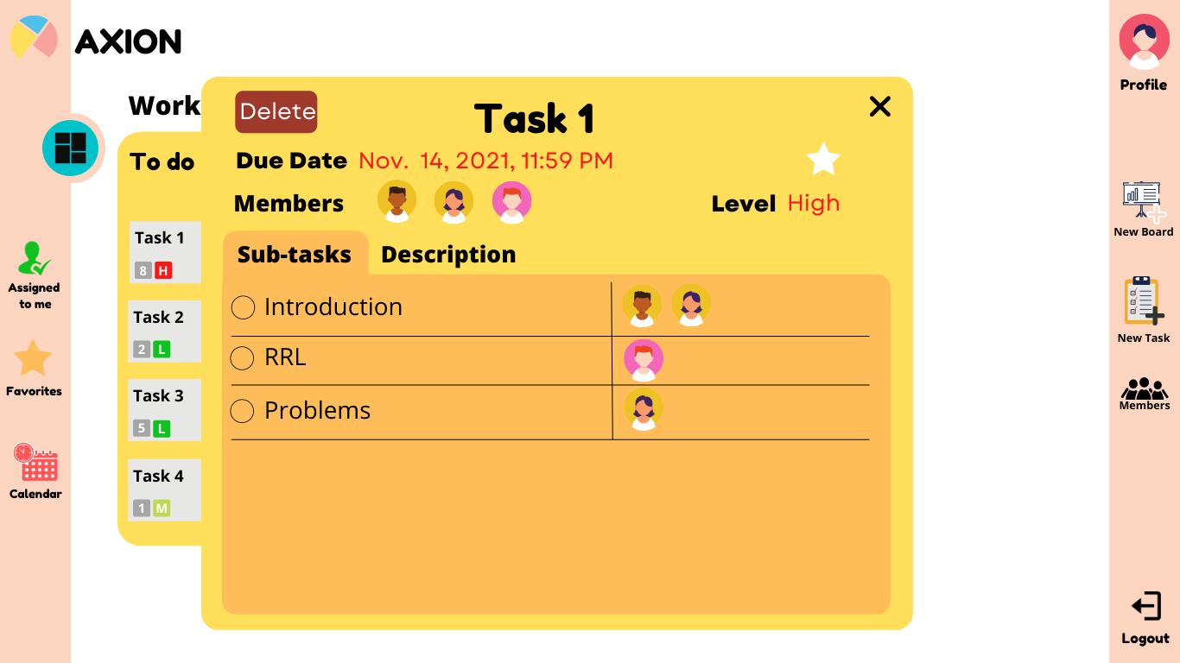

**15**

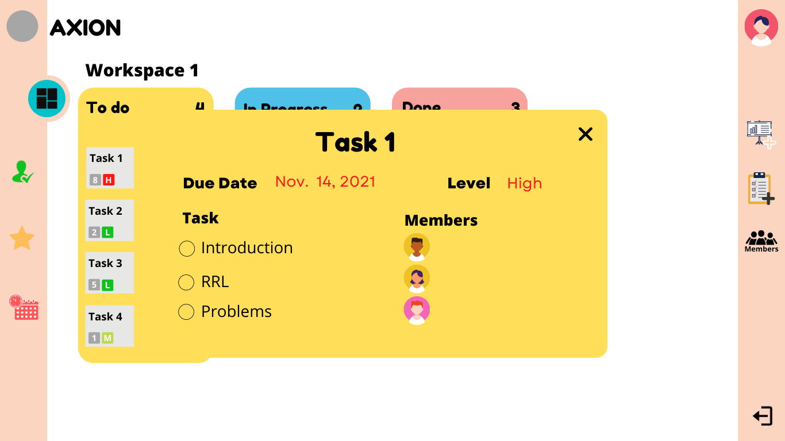

**15a**

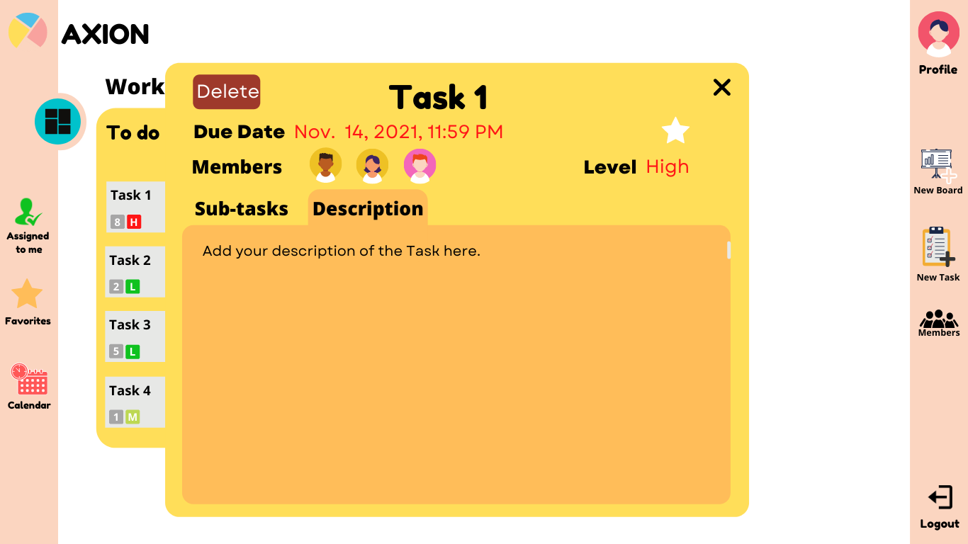

As for this screen, the description area can be used to note specific details about a certain task or subtask. So that is when users want to know something about a task, they will be able to relearn the task.

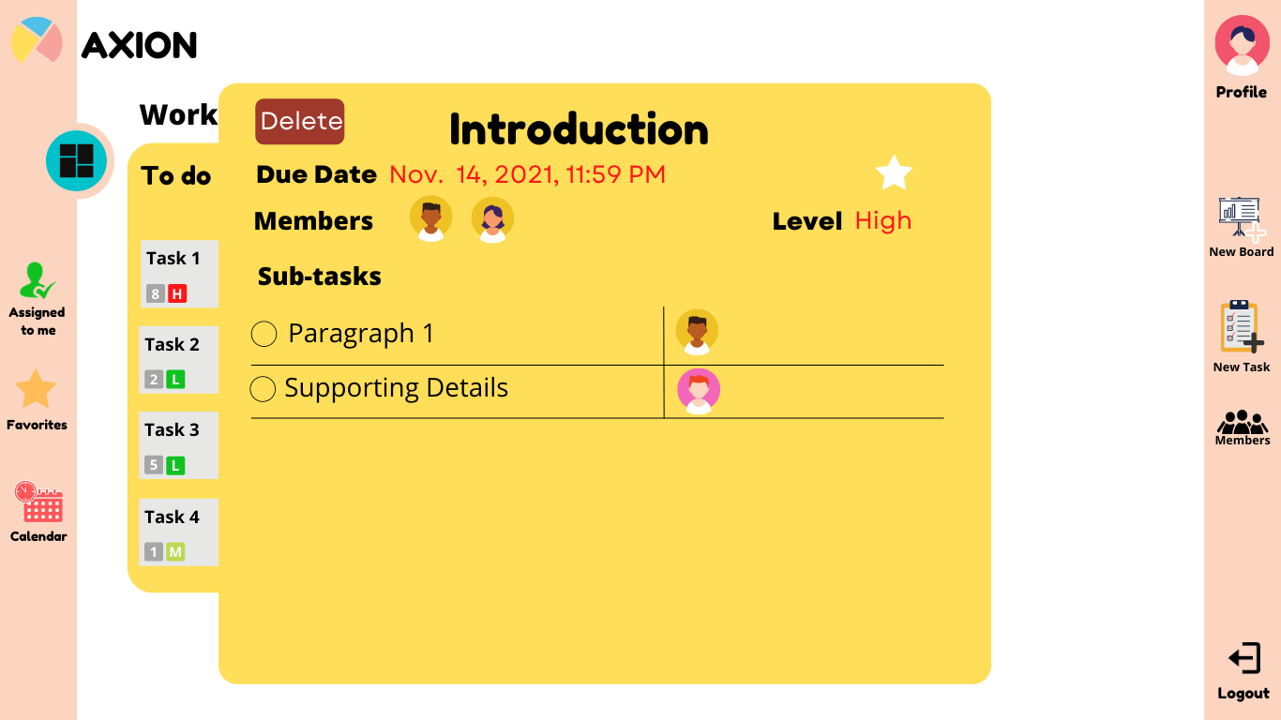

**17**

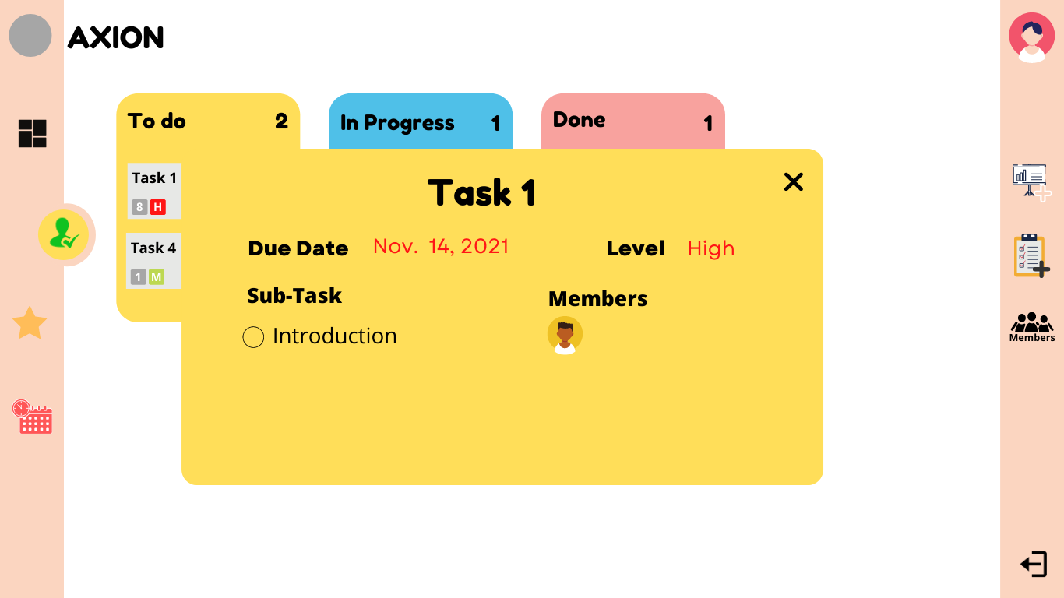

**17a**

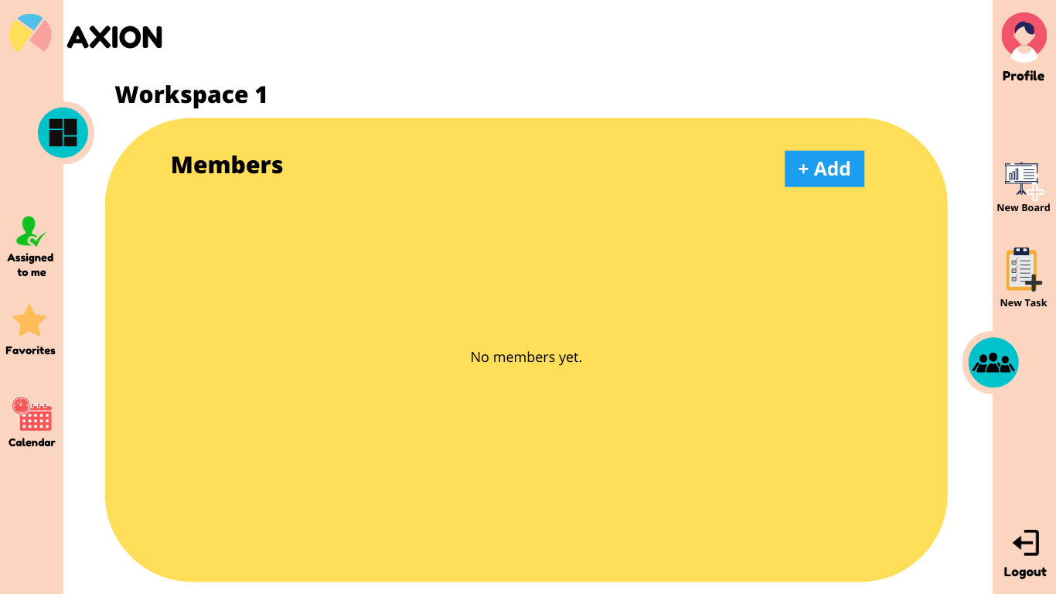

**18**

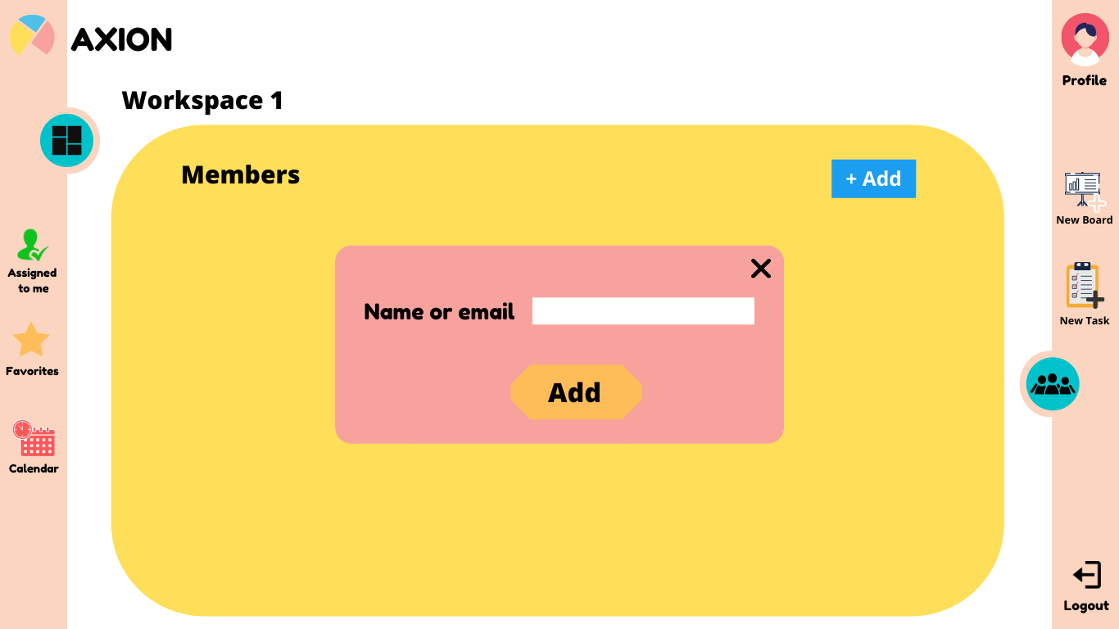

**19**

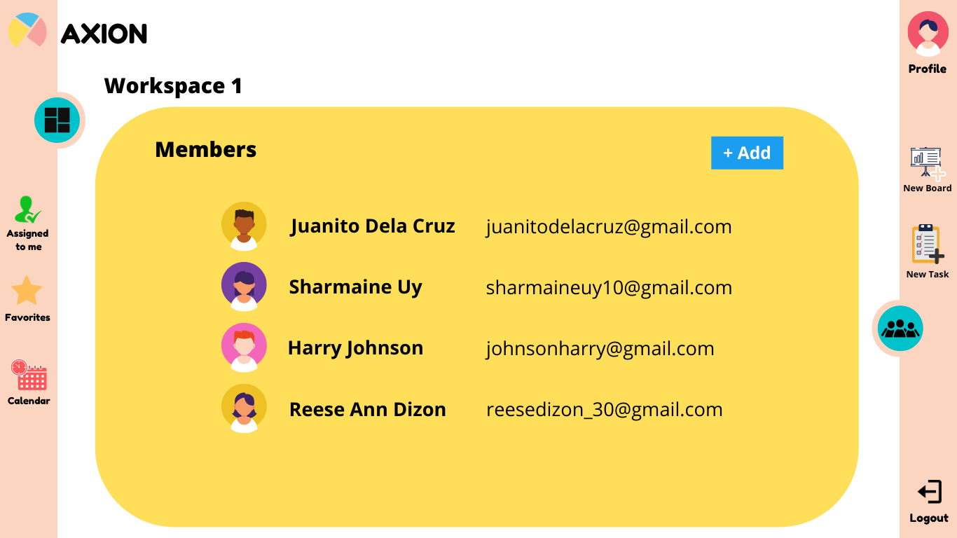

Four members are seen to be invited and added to the workspace.

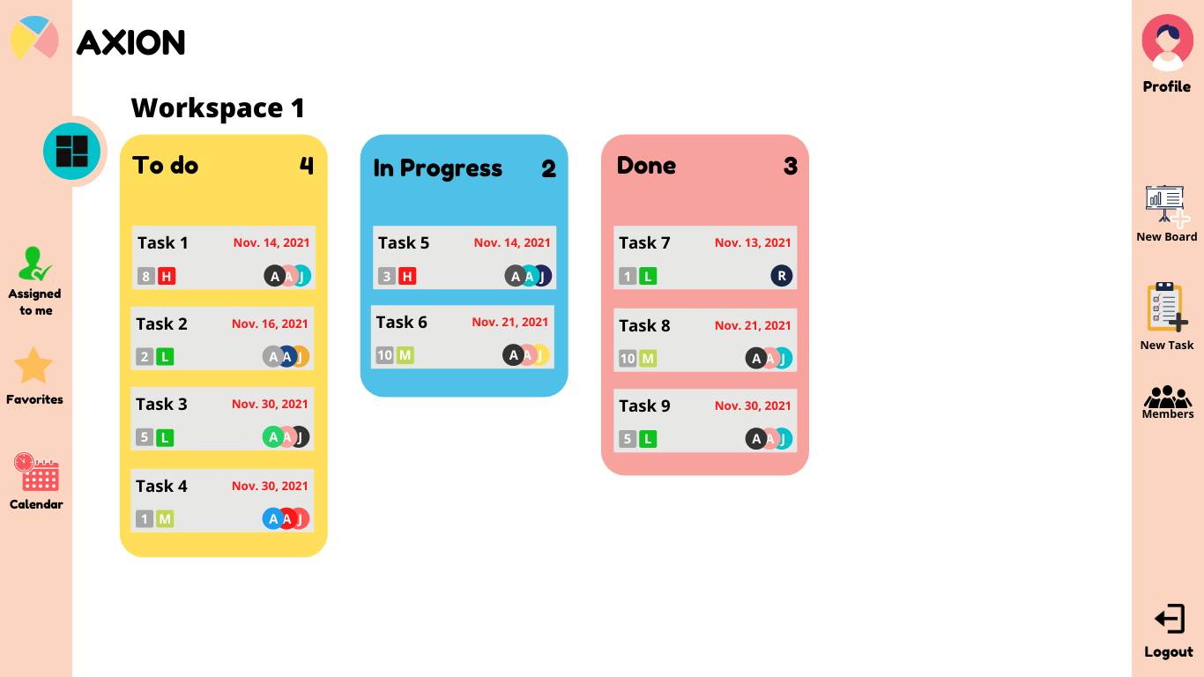

**21**

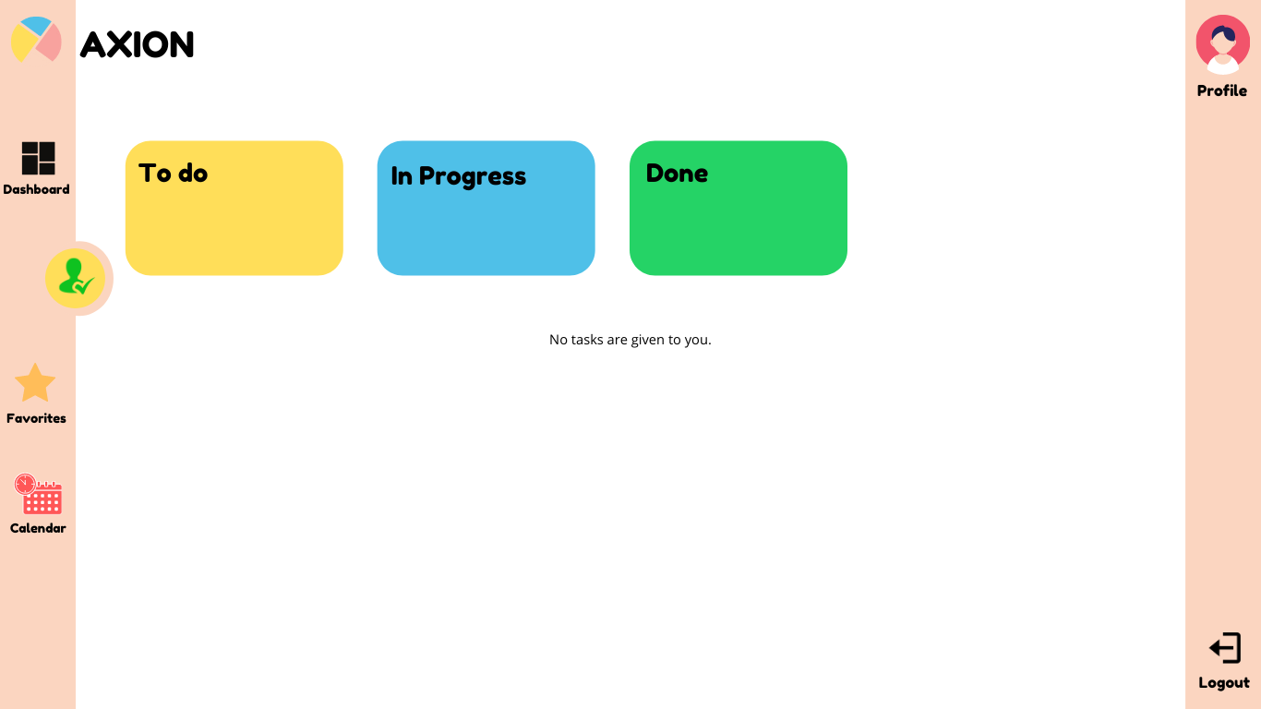

**22**

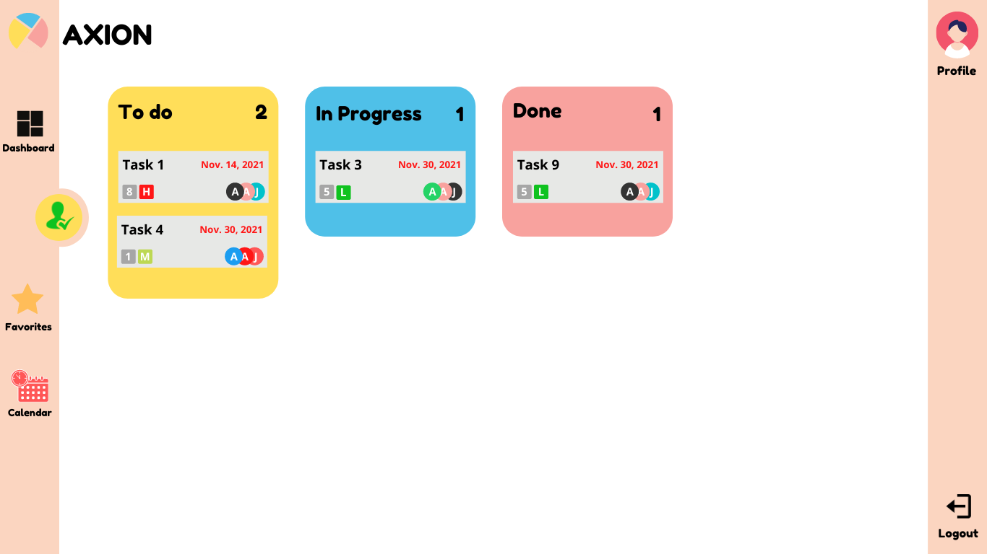

**23**

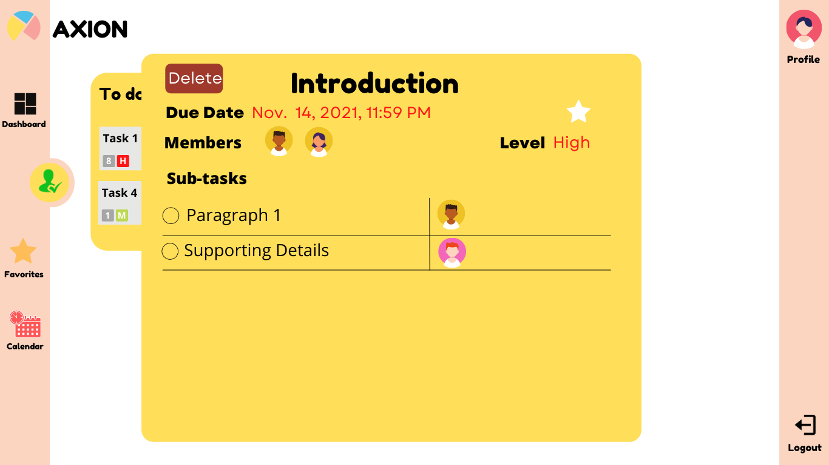

**24**

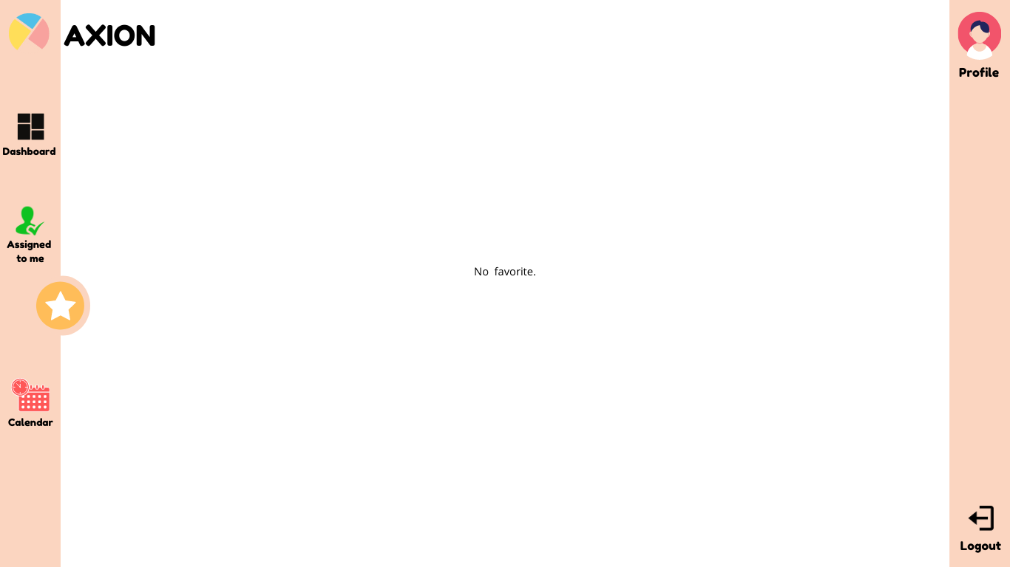

**25**

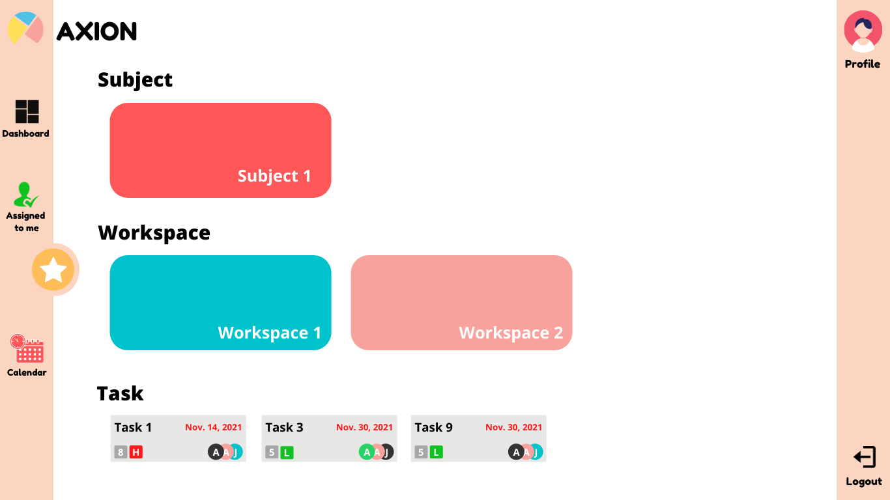

**26**

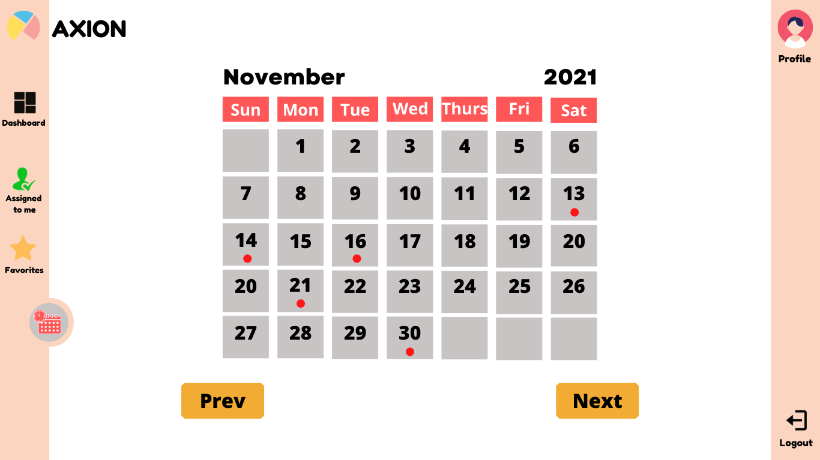

**27**

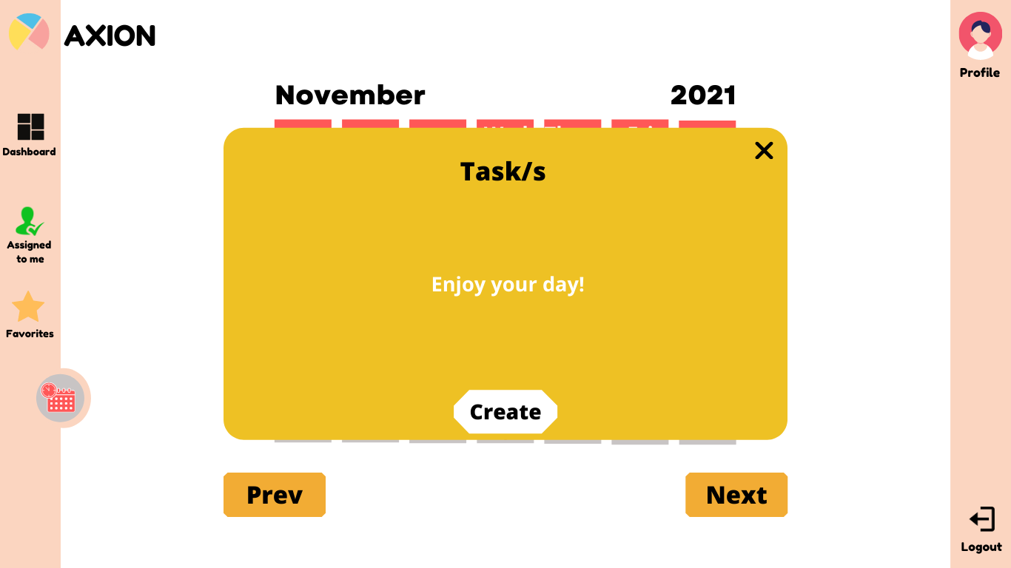

After clicking a certain day, a yellow box will appear, showing any tasks that are being set on that day. As seen on this design, it shows a message ‘Enjoy your day!’ which pertains that as of that day, there are no tasks being set. Therefore, Axion intends to greet the user, pointing out that the day could be a chance for users to take a break or do other things besides non-academic related tasks.

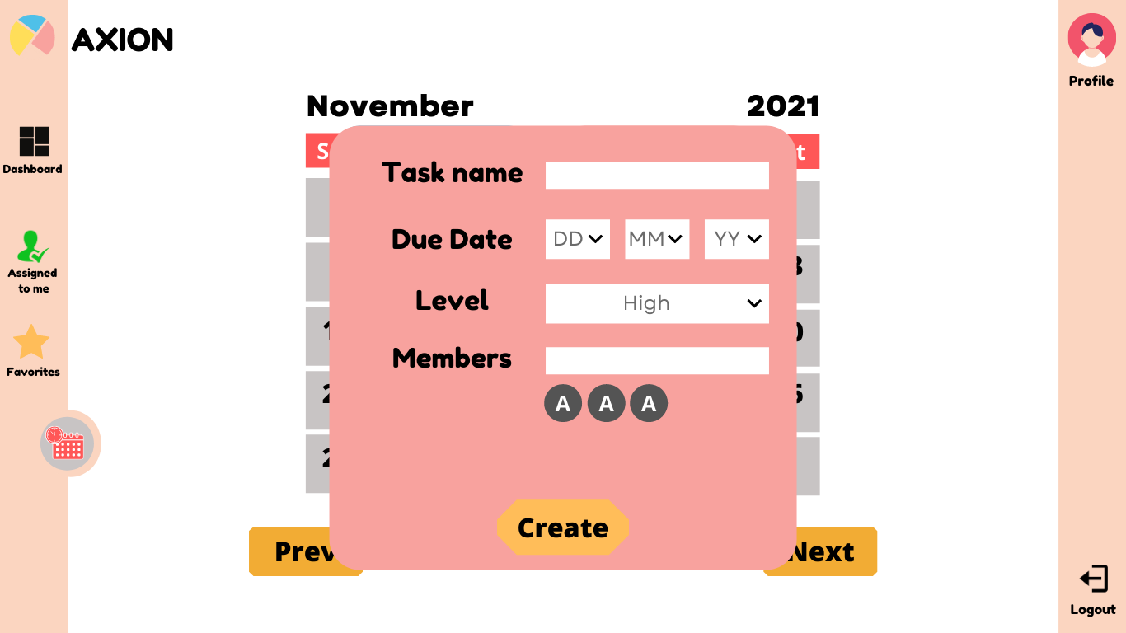

**29**

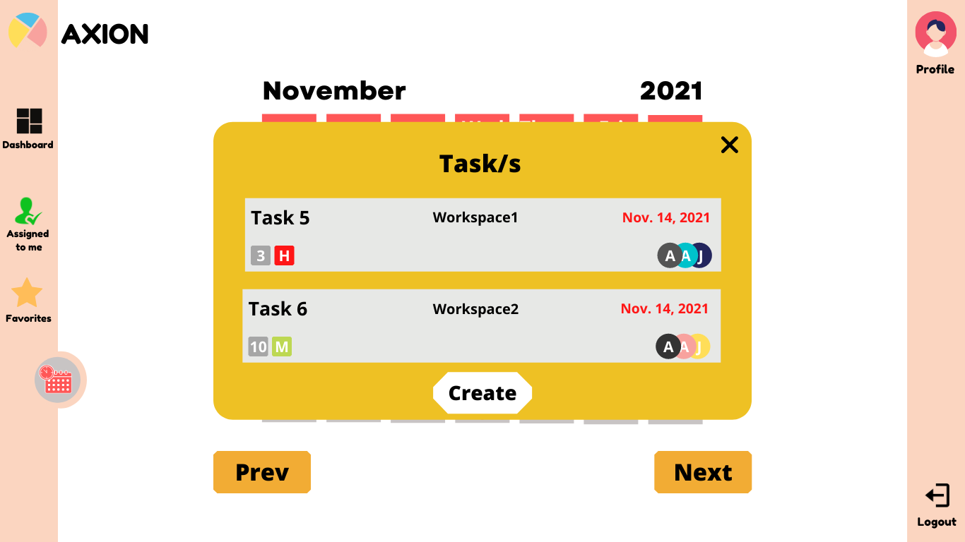

**30**

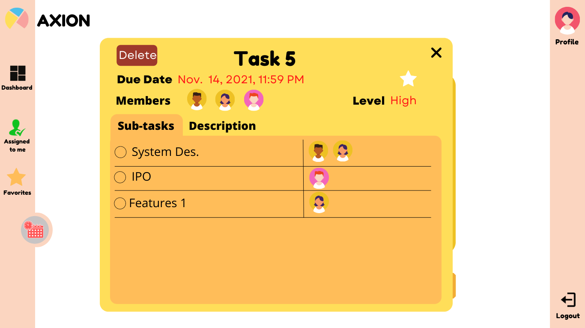

**31**

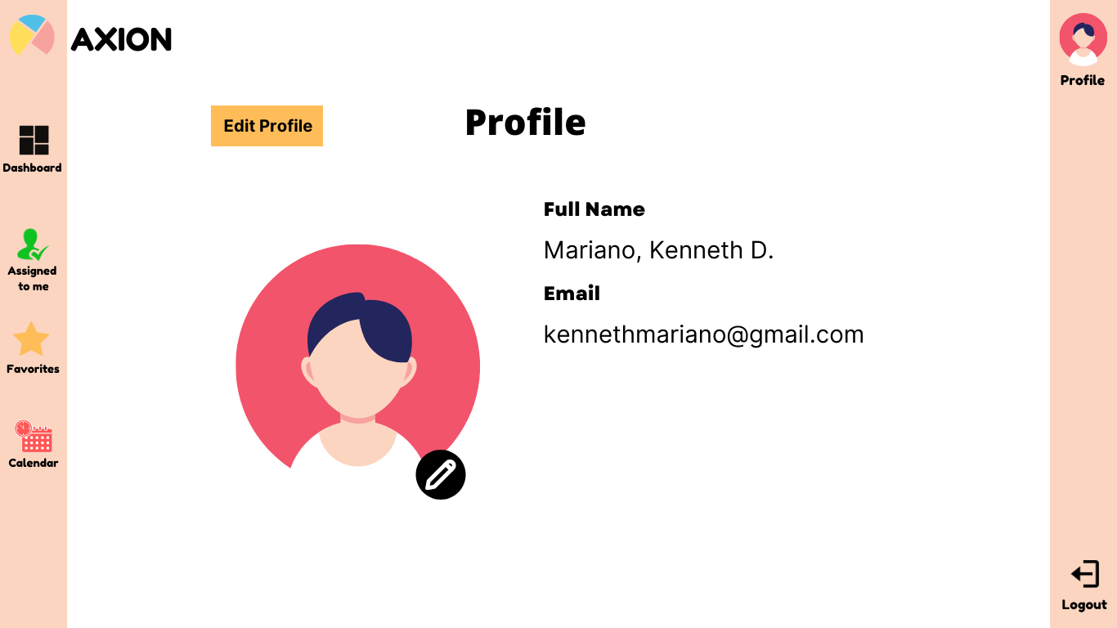

This shows the profile interface which can be clicked on the top right picture along with the word, ‘Profile’. Certain details such as the full name and the email can be seen besides the picture of the user. There is also a yellow button that says, ‘Edit Profile’, which enables users to modify certain credentials of their account.

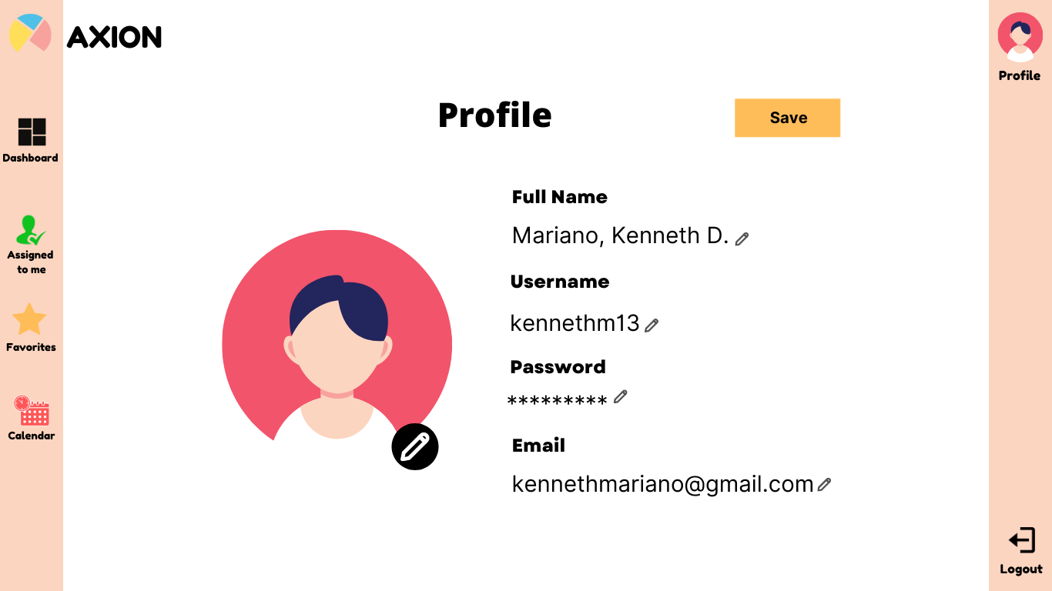

By clicking the ‘Edit Profile’, users can be able to modify some account details by clicking on the small pencil icon right after every detail. Once the user is done editing, they can save the new details, which will update their data within the database.

**FORM 3**

No. V8_3-9

**Form 3: RESEARCH/CAPSTONE CONSULTATION RECORD**

No. V8-3

*Please write legibly and in BLOCK LETTERS.*

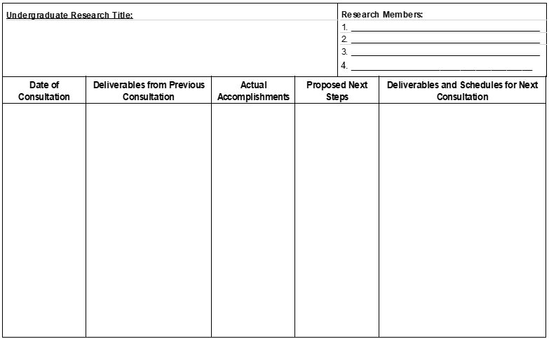

Chapter 1 & 2

11/25/21

11/09/21

Chapter 1 & 2

Revised title, re-finalize chapter 1, and re-finalize chapter 2

Revise title and chapter 2 to re-finalize chapter 1, and other parts.

Chapter 1

& 2

ROCHE, JOANNE RAZELLE L.

MATIMTIM, EL JOHN S.

CLARIN, MART YAZEN MIKHAIL

HERRERA, CHARLES MAVERICK

Title

Finish the chapter 2 to re-finalize chapter 1 and other parts of research.

N/A

*To the students:* Always bring previous Consultation Record during your consultation hours with the technical adviser. Students should accomplish this form.

*To the technical adviser:* Kindly implement a “No previous Consultation Record, no Consultation policy”.

Use another sheet if necessary. Please write clearly and legibly on this document. All Consultation Records shall be compiled and will be part of the Appendix of your final manuscript.

___________________________

Faculty Technical Adviser

*(Signature over printed name/Date)*